How will I know how my child is doing, and how will you help me to support my child ’s learning?  You will be able to discuss your child ’s progress and needs at termly meetings and at parents’ evenings  You will receive a written annual report detailing your child ’s progress and achievements from your child ’s teacher  If you have any concerns you may make an additional appointment to speak to your child ’s class teacher  Your child ’s targets will be shared with you  The class teacher may suggest ways of how you can support your child at home and share with you strategies that work well in school.  How is the decision made about what type and how much support my child will receive?  The decision about how best to support your child is based on the needs of your child | Decisions are made in consultation with the class teacher, SENDCo and Headteacher  The curriculum is differentiated to meet the needs of all children and is planned and delivered by your child ’s class teacher. After discussing your child ’s specific needs with you, the class teacher may take the decision to provide additional support if your child is not making the expected progress in any particular area  Decisions are made based on rigorous assessment and monitoring activities which highlight the areas in which your child may need additional support  If your child ’s teacher decides that your child needs specialised help or targeted support this will be discussed with the SENDCo who will determine if specialist advice is needed  Guidance may be sought from outside agencies regarding the type of support provided for your child  The outcomes of all targeted support are closely monitored, assessed and reviewed. |   Supporting Children with Special Educational Needs and Disabilities  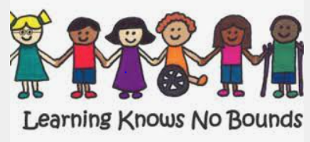  Information for Parents and Carers  If you would like to discuss your child ’s Special Educational Needs, please contact the school office on 01924 303700 to arrange a meeting with the SENDCo – Mrs Rowlands.

At Pinders Primary School we aim to provide a broad and balanced curriculum with high expectations and suitable targets for all. We understand that some children experience greater difficulty in their learning compared to those of the same age. Our aim is to ensure children are given a level of support to meet their individual needs in order for them to achieve and be successful learners.    What does Special Educational Needs mean?  Children have special educational needs if they have a learning difficulty which calls for special educational provision to be made for them. | Types of SEND Special Educational Needs and Disability is divided into 4 types (as stated in the 2014 SEND Code of Practice):  1. Communication and Interaction difficulties – this includes children with speech and language delay, impairments or disorders, specific learning difficulties such as dyslexia, dyscalculia, dysgraphia, hearing Impairment, and those who demonstrate features within the autistic spectrum  2. Cognition and Learning difficulties – this includes children who demonstrate features of moderate, severe or profound learning difficulties or specific learning difficulties such as dyslexia, dyscalculia, dysgraphia or dyspraxia  3. Social, Mental and Emotional Health difficulties - this includes children who may be withdrawn or isolated, disruptive or disturbing, hyperactive or lack concentration  4. Sensory and/or Physical Needs – this includes children with sensory, multisensory and physical needs | A Graduated Approach to SEN Support At Pinders Primary, we adopt a “high quality teaching” approach.  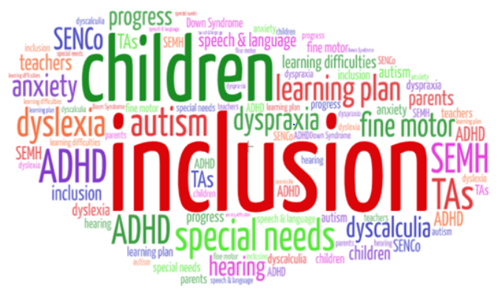  If concerns are raised, the following graduated approach will be followed using specialist support if required.  - Areas of concern raised with parents or school  - SEN school support may be initiated and a Learner Profile or Supporting Me to Learn Plan may be issued  - For children with greater SEN a My Support Plan may be created with a multi agency approach  - School may then make a request for ‘Statutory Assessment’  - This may result in an EHCP (Education, Health and Care Plan)  - If a child has an EHCP there will be an annual review of need.

