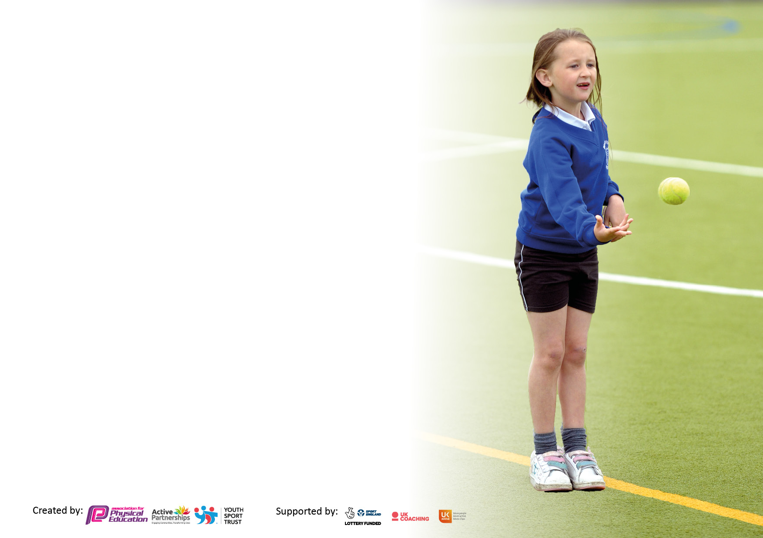

It is important that your grant is used effectively and based on school need. The Education Inspection Framework makes clear there will be a focus on **‘whether leaders and those responsible for governors all understand their respective roles and perform these in a way that enhances the effectiveness of the school’**.

Under the Quality of Education Ofsted inspectors consider:

**Intent** - Curriculum design, coverage and appropriateness

**Implementation** - Curriculum delivery, Teaching (pedagogy) and Assessment

**Impact** - Attainment and progress

To assist schools with common transferable language this template has been developed to utilise the same three headings which should make your plans easily transferable between working documents.

Schools must use the funding to make **additional and sustainable** improvements to the quality of Physical Education, School Sport and Physical Activity (PESSPA) they offer. This means that you should use the Primary PE and sport premium to:

* Develop or add to the PESSPA activities that your school already offer
* Build capacity and capability within the school to ensure that improvements made now will benefit pupils joining the school in future years
* The Primary PE and sport premium should not be used to fund capital spend projects; the school’s budget should fund these.

Please visit gov.uk for the revised DfE guidance including the5keyindicatorsacrosswhichschoolsshoulddemonstrate an improvement. This document will helpyoutoreviewyourprovisionandtoreportyourspend.DfEencouragesschools to use this template as an effective way of meeting the reporting requirements of the Primary PE and Sport Premium.

We recommend you start by reflecting on the impact of current provision and reviewing the previous spend.

Schools are required to publish details of how they spend this funding, including any under-spend from 2021/2022, as well as on the impact it has on pupils’ PE and sport participation and attainment. The funding **should** be spent by 31st July but the DfE has stated that there will be **no clawback** of any unspent money so this can be carried forward into 2023/24.

We recommend regularly updating the table and publishing it on your website throughout the year. This evidences your ongoing self-evaluation of how you are using the funding to secure maximum, sustainable impact. Final copy must be posted on your website by the end of the academic year and no later than the 31st July 2023. To see an example of how to complete the table please click HERE.

**Details with regard to funding**

Please complete the table below.

|  |  |
| --- | --- |
| Total amount carried over from 2022/23 | £0 |
| Total amount allocated for 2022/23 | £0 |
| How much (if any) do you intend to carry over from this total fund into 2023/24 | £ 0 |
| Total amount allocated for 2023/24 | £18,000 |
| Total amount of funding for 2023/24. **Ideally should** be spent and reported on by 31st July 2024. | £ 018,000 |

**Swimming Data**

Please report on your Swimming Data below.

|  |  |
| --- | --- |
| Meeting national curriculum requirements for swimming and water safety.  N.B. Complete this section to your best ability. For example you might have practised safe self-rescue techniques on dry land which you can then transfer to the pool when school swimming restarts. | 26% |
| What percentage of your current Year 6 cohort swim competently, confidently and proficiently over a distance of at least 25 metres?  **N.B.** Even though your pupils may swim in another year please report on their attainment on leaving primary school at the end of the summer term 2023.  Please see note above | 40% |
| What percentage of your current Year 6 cohort use a range of strokes effectively [for example, front crawl, backstroke and breaststroke]?  Please see note above | 26% |
| **What percentage of your current Year 6 cohort perform safe self-rescue in different water-based situations?** | 26% |
| Schools can choose to use the Primary PE and sport premium to provide additional provision for swimming but this must be for activity **over and above** the national curriculum requirements. Have you used it in this way? | No ( looking at 24/ 25 to add in extra swimming, can ot secure pool facilities this year) |

**Action Plan and Budget Tracking**

Capture your intended annual spend against the 5 key indicators. Clarify the success criteria and evidence of impact that you intend to measure to evaluate for pupils today and for the future.

|  |  |  |  |  |
| --- | --- | --- | --- | --- |
| **Academic Year:** 2023/24 | **Total fund allocated: £18,000** | **Date Updated: 09/24** | |  |
| **Key indicator 1:** The engagement of all pupils in regular physical activity – Chief Medical Officers guidelines recommend that primary school pupils undertake at least 30 minutes of physical activity a day in school | | | | Percentage of total allocation: |
| 61% **£10,998.50** |
| **Intent** | **Implementation** | | **Impact** |  |
| Your school focus should be clear what you want the pupils to know and be able to do and about  what they need to learn and to  consolidate through practice: | Make sure your actions to achieve are linked to your intentions: | Funding allocated: | Evidence of impact: what do pupils now know and what can they now do? What has changed?: | Sustainability and suggested next steps: |
| Provision for all children to access Forest Schools to build confidence and knowledge in regards to the outdoor curriculum.  To continue to develop our outside provision and delivery of activities at break and lunchtimes  Maintaining and developing the outdoor environment to ensure it remains stimulating and gives additional opportunities for physical exercise and team work. | Forest School booked for a full day a week for the whole year and timetabled for all classes to receive 6-7 weeks of lessons.  Appointing a sports leader to coordinate and lead on lunchtime activities  Replenish sports equipment, scooters and construction pit equipment. | £ 4580  September to July  Cost Salary -£3,802  Scooters £205.50 each x 3 £616.50  Other equipment - £2,000 | All children have received forest schools. Pupils Voice is positive and children’ confidence improved. Children understand fire safety, how to build a den. Team sports and co operation. From nursery to Year 6 at age appropriate levels.  Provision has been co ordinated for football , cricket and basket ball. Pupil engagement is high in these predominantly boys. Pupil Voice is that they would like less football next year and more cricket and hockey.  Equipment has been refurbished and will need doing again for September as very well used. | Continue with Forest Schools as this is an experience that out inner City school pupils do not experience otherwise. A lot of the pupils do not have garden spaces and culturally they are not exposed to different weather conditions. All of these are character building, develop essential life skills, collaborative learning and resilience. They also reinforce the school values including Respect.  Outdoor space will continue to be developed listening to pupil voice. The PE lunchtime lead has been extended to continue to co ordinate next year. |
| **Key indicator 2:** The profile of PESSPA being raised across the school as a tool for whole school improvement | | | | Percentage of total allocation: |
| 4% £750 |
| **Intent** | **Implementation** | | **Impact** |  |
| Your school focus should be clear what you want the pupils to know and be able to do and about  what they need to learn and to  consolidate through practice: | Make sure your actions to achieve are linked to your intentions: | Funding allocated: | Evidence of impact: what do pupils now know and what can they now do? What has changed?: | Sustainability and suggested next steps: |
| To continue to provide a major contribution to the strategic leadership of school improvement, by ensuring effective subject leadership of PE, within the context of the wider school curriculum.  Impact on pupils: By July 2024, a broad and balanced PE Curriculum provides for all children, thus ensuring that all PE T&L is consistently good or better  Hockey goals to be purchased and hockey sticks | PE subject leader training and release including the West Yorkshire PE conference  Implementation and monitoring of the GET Set for EDUCATION as a new scheme.  Support the teaching of hockey and to be used for playground activities. | £400  Cost allocated in KP 3  £ 350 | Training attended, impact from this has been with regards to outdoor adventure unit of work and improving provision for the next cycle. Revising swimming.  Networking for clubs and interschools sports for next year.  Get set Education has been successfully delivered. The cycles have been reviewed for next year.  The teaching is consistent and of a higher standard | To attend the training again next year.  To monitor the provision of education through following the scheme for our second cycle. Monitoring teaching standards o ensure they are good. |

|  |  |  |  |  |
| --- | --- | --- | --- | --- |
| **Key indicator 3:** Increased confidence, knowledge and skills of all staff in teaching PE and sport | | | | Percentage of total allocation: |
| 3% £550 |
| **Intent** | **Implementation** | | **Impact** |  |
| Your school focus should be clear | Make sure your actions to | Funding | Evidence of impact: what do | Sustainability and suggested |
| what you want the pupils to know | achieve are linked to your | allocated: | pupils now know and what | next steps: |
| and be able to do and about | intentions: |  | can they now do? What has |  |
| what they need to learn and to |  |  | changed?: |  |
| consolidate through practice: |  |  |  |  |
| To further develop the quality of PE lessons throughout the school, so teaching is continuously good or better. To continue to support teachers when delivering a variety of different sports to the children.  Impact on pupils: By July 2024, a broad and balanced PE Curriculum provides for all children, thus ensuring that all PE T&L is consistently good or better. | The implementation of a new scheme with a two year cycle to accommodate the vertically grouped classes  A wide range of sports is offered within this  Scheme – Get Set for Education  To continue to provide Year2 and 5 with the Ackworth Outreach Offer – Table Tennis and Tennis coaching | £550 | Get set Education has been successfully delivered. The cycles have been reviewed for next year.  The teaching is consistent and of a higher standard.  Delivered by Ackworth positive pupil voice. High levels of engagement. | Get Set to continue next academic year to complete the two cycles.  Following this the scheme will be fully implemented and if successful when reviewed become part of the annual subscription budget moving forward. |
| **Key indicator 4:** Broader experience of a range of sports and activities offered to all pupils | | | | Percentage of total allocation: |
| 35% £6,220 |
| **Intent** | **Implementation** | | **Impact** |  |
| Your school focus should be clear | Make sure your actions to | Funding | Evidence of impact: what do | Sustainability and suggested |
| what you want the pupils to know | achieve are linked to your | allocated: | pupils now know and what | next steps: |
| and be able to do and about | intentions: |  | can they now do? What has |  |
| what they need to learn and to |  |  | changed?: |  |
| consolidate through practice: |  |  |  |  |
| Additional achievements:  Additional achievements:  Clubs –  Hockey  Pro football  Forest Schools  Residential trip to Nell Bank for Year 6 outdoor adventure activities  Subsidised places  Subsidised camping places for Year 6 | Contact providers  Arrange clubs across the year with providers and with staff.  Monitor attendance  Forest School booked for a full day a week for the whole year and timetabled for all classes to receive 6-7 weeks of lessons  Overnight camping for Years 6 Booked through Forest Schools | £Football £1,560  Forest School £2,660  £1,000  £1,000 | Clubs well attended and positive feedback from parental engagement group and pupil voice.  ( Add in club Data in September)  Forest school cub always oversubscribed.  ( add in number of pupil who attended number subsidised)  This was not able to run. The Year 6 pupils were funded for a trip to gravity trampoline park instead. Whole school were funded to take part in a mini- mudder which was an assault course with a 100ft inflatable. | Clubs will continue next year. Septembers have been advertised already.  Tag Rugby has been arranged for three classes with the Wakefield Trinity this is to enhance the rugby provision from get set for PE.  Look to booking Ackworth again next year  Residential booked for September. There will be subsidized places offered again. This is an experience the children will not otherwise access.  Pupil Voice will be sought regarding a reward outing that is physically active for the |Year 6 pupils next year. This may be funded by the PTFA next year to make this sustainable moving forward. |

|  |  |  |  |  |
| --- | --- | --- | --- | --- |
| **Key indicator 5:** Increased participation in competitive sport | | | | Percentage of total allocation: |
| % |
| **Intent** | **Implementation** | | **Impact** |  |
| Your school focus should be clear | Make sure your actions to | Funding | Evidence of impact: what do | Sustainability and suggested |
| what you want the pupils to know | achieve are linked to your | allocated: | pupils now know and what | next steps: |
| and be able to do and about | intentions: |  | can they now do? What has |  |
| what they need to learn and to |  |  | changed?: |  |
| consolidate through practice: |  |  |  |  |
| Competitive Sports Day  PE leader to look for competitive opportunities with other schools  Continue links with ???  Make links with Outwood academy City Fields?  Look for opportunities within Wakefield Trust. | PE lead to organise a sports day with competitive element. Trophies and Medals. | £ | Sports Day was run as competitive sports very successful.  Included Tug Of War which was new.  Competitive sports with other schools still difficult to arrange. Transport and staffing a barrier and events are not organized in advance enough for school to plan | Run the sports Day with the same format.  PE Leader continues to research and make links to get some events running. |

|  |  |
| --- | --- |
| Signed off by | |
| Head Teacher: | L F kemplay |
| Date: | 31/07/24 |
| Subject Leader: | K Hargreaves |
| Date: | 31/07/24 |
| Governor: | Stuart Heptinstall |
| Date: | 31/07/24 |