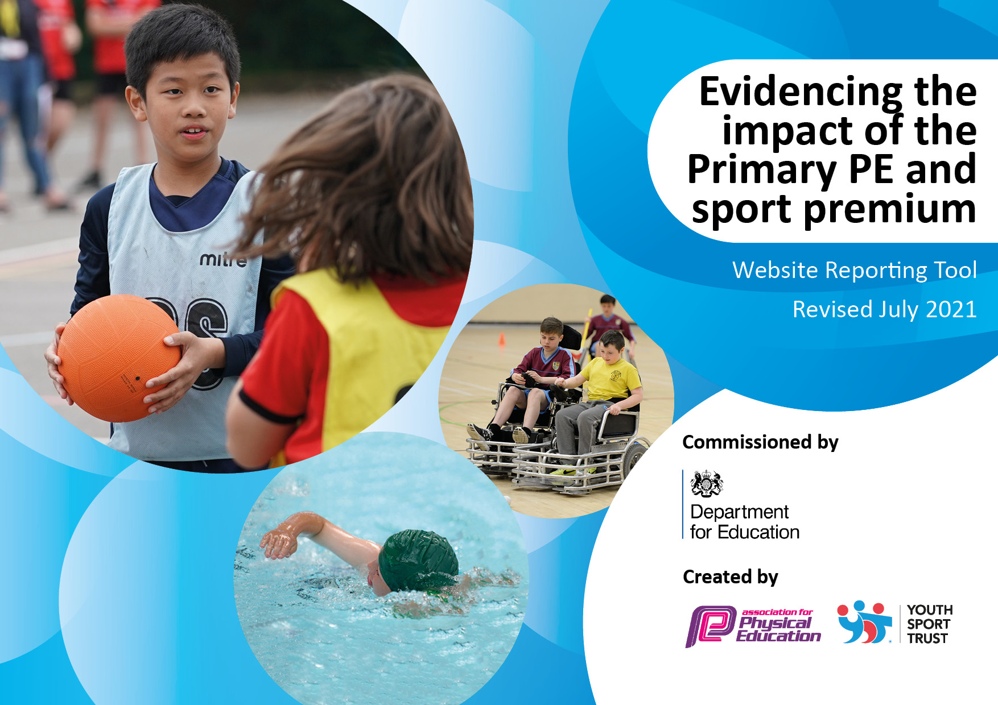

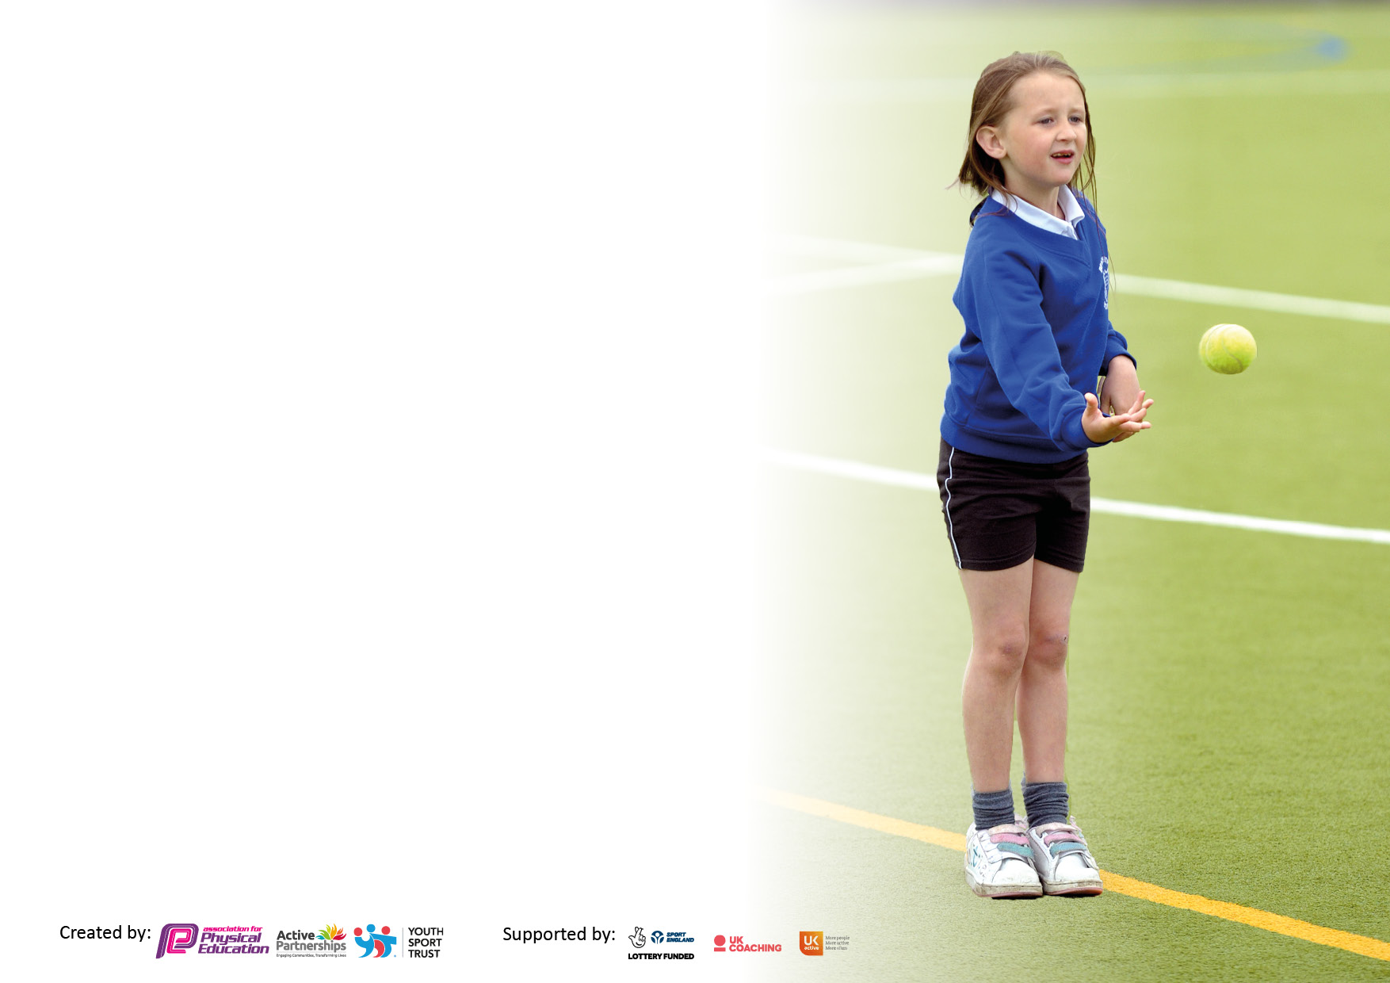

It is important that your grant is used effectively and based on school need. The Education Inspection Framework makes clear there will be a focus on **‘whether leaders and those responsible for governors all understand their respective roles and perform these in a way that enhances the effectiveness of the school’**.

Under the Quality of Education Ofsted inspectors consider:

**Intent** - Curriculum design, coverage and appropriateness

**Implementation** - Curriculum delivery, Teaching (pedagogy) and Assessment

**Impact** - Attainment and progress

To assist schools with common transferable language this template has been developed to utilise the same three headings which should make your plans easily transferable between working documents.

Schools must use the funding to make **additional and sustainable** improvements to the quality of Physical Education, School Sport and Physical Activity (PESSPA) they offer. This means that you should use the Primary PE and sport premium to:

* Develop or add to the PESSPA activities that your school already offer
* Build capacity and capability within the school to ensure that improvements made now will benefit pupils joining the school in future years
* The Primary PE and sport premium should not be used to fund capital spend projects; the school’s budget should fund these.

Pleasevisitgov.ukfortherevisedDfEguidanceincludingthe5keyindicatorsacrosswhichschoolsshoulddemonstrate animprovement.Thisdocumentwillhelpyoutoreviewyourprovisionandtoreportyourspend.DfEencouragesschools to use this template as an effective way of meeting the reporting requirements of the Primary PE and sport premium.

We recommend you start by reflecting on the impact of current provision and reviewing the previous spend.

Schools are required to publish details of how they spend this funding, including any under-spend from 2019/2020, as well as on the impact it has on pupils’ PE and sport participation and attainment. **All funding must be spent by 31st July 2022.**

We recommend regularly updating the table and publishing it on your website throughout the year. This evidences your ongoing self-evaluation of how you are using the funding to secure maximum, sustainable impact. Final copy must be posted on your website by the end of the academic year and no later than the 31st July 2021. To see an example of how to complete the table please click HERE.

Created by: Supported by:

**Details with regard to funding**

Please complete the table below.

|  |  |
| --- | --- |
| Total amount carried over from 2019/20 | £6095 |
| Total amount allocated for 2020/21 | £17,786 |
| How much (if any) do you intend to carry over from this total fund into 2021/22? | £11,883.50 |
| Total amount allocated for 2021/22 | £10634 |
| Total amount of funding for 2021/22. To be spent and reported on by 31st July 2022. | £22,517.50 |

**Swimming Data**

Please report on your Swimming Data below.

|  |  |
| --- | --- |
| Meeting national curriculum requirements for swimming and water safety.  N.B. Complete this section to your best ability. For example you might have practised safe self-rescue techniques on dry land which you can then transfer to the pool when school swimming restarts.  **Due to exceptional circumstances priority should be given to ensuring that pupils can perform safe self rescue even if they do not fully meet the first two requirements of the NC programme of study** |  |
| What percentage of your current Year 6 cohort swim competently, confidently and proficiently over a distance of at least 25 metres?  **N.B.** Even though your pupils may swim in another year please report on their attainment on leaving primary school at the end of the summer term 2020.  Please see note above |  |
| What percentage of your current Year 6 cohort use a range of strokes effectively [for example, front crawl, backstroke and breaststroke]?  Please see note above |  |
| **What percentage of your current Year 6 cohort perform safe self-rescue in different water-based situations?** |  |
| Schools can choose to use the Primary PE and sport premium to provide additional provision for swimming but this must be for activity **over and above** the national curriculum requirements. Have you used it in this way? |  |

**Action Plan and Budget Tracking**

Capture your intended annual spend against the 5 key indicators. Clarify the success criteria and evidence of impact that you intend to measure to evaluate for pupils today and for the future.

|  |  |  |  |  |
| --- | --- | --- | --- | --- |
| **Academic Year:** 2020/21 | **Total fund allocated:** | **Date Updated:** | |  |
| **Key indicator 1:** The engagement of all pupils in regular physical activity – Chief Medical Officers guidelines recommend that primary school pupils undertake at least 30 minutes of physical activity a day in school | | | | Percentage of total allocation: |
| % |
| **Intent** | **Implementation** | | **Impact** |  |
| Your school focus should be clear what you want the pupils to know and be able to do and about  what they need to learn and to  consolidate through practice: | Make sure your actions to achieve are linked to your intentions: | Funding allocated: | Evidence of impact: what do pupils now know and what can they now do? What has changed? | Sustainability and suggested next steps: |
| Provision for all children to access Forest Schools to build confidence and knowledge in regards to the outdoor curriculum.  Creating an outdoor environment that is stimulating and gives additional opportunities for physical exercise and team work.  Playground equipment / Gym  Skipathon  Staging for outdoor dance | Forest School booked for a full day a week for the whole year and timetabled for all classes to receive 6-7 weeks of lessons.  Plan out areas that provide exercise and opportunities for Team Work.  Order materials and labour to complete the building work.  Gain a quote from an external company.  Arrange for fitting.  Staff and children to be inducted on how to us each piece of equipment.  A member of staff to be allocated to gym area during outdoor breaks.  The use of the gym equipment to be incorporated into PE lessons.  Audit of playground equipment to be completed and order placed.  Children to receive an assembly about the benefits of exercise and how good skipping is. Link this to keeping your heart healthy.  Fundraising letter to be sent out to parents, school council to select a charity to share the funds raised with.  School to purchase ropes for every child to practice with and then after Skipathon take home, to encourage them to continue with exercise. | £ 4,180  April to July  £2,090  Cost of labour  Cost of equipment/ resources.  £1,000  £200  £2000 | Leaders have ensured that the PE curriculum is very well-resourced. This includes significant investment, though the use of the Sports Premium and other revenue streams, into the design and development of extensive outdoor physical learning opportunities such as the trim trail, outdoor and adventurous environments, the EYFS physical development outdoor provision and Forest School learning to name a few.  PE DEEP DIVE 2022  All pupils accessed forest schools and were positive I their feedback. The children gained team building skills and resilience.  Outdoor provision has resulted in greater physical activity at break and lunchtimes.  The Skipathon did not take place instead Race for life was completed y all children.  Outdoor stage is complete and pupils access tis at playtimes and can also use for outdoor PE lessons. |  |
| **Key indicator 2:** The profile of PESSPA being raised across the school as a tool for whole school improvement | | | | Percentage of total allocation: |
| % |
| **Intent** | **Implementation** | | **Impact** |  |
| Your school focus should be clear what you want the pupils to know and be able to do and about  what they need to learn and to  consolidate through practice: | Make sure your actions to achieve are linked to your intentions: | Funding allocated: | Evidence of impact: what do pupils now know and what can they now do? What has changed?: | Sustainability and suggested next steps: |
| Forest Schools to reflect topic led sessions to build upon knowledge and skills of their Pinders designed curriculum.  Gym equipment for PE lessons and also for additional outside opportunities  Installing Crazy Golf  Scheme of work to be fully implemented across school with a clear progression of skills.  This to include knowledge about sports persons. | All children to experience forest schools with a link to their topic. Increased physical activity and engagement with the outdoors.  Ordered and fitted before end of September.  Staff and Pupils inducted on correct use of the equipment.  Stop watches added to encourage circuit training activities in PE | £1,320  £1,000  £3,000  £1,000 | All children have engaged and are able to talk about their skills learnt  Equipment is installed and used at break and lunch it is also used during some PE lessons.  Crazy Golf was not installed instead a tyre climbing area has been created.  Scheme of work is implemented  Skills progression maps through Y1-Y6 are clear, coherent and well-sequenced however sometimes lack the detail some staff need to teach PE well (please see notes above).  SIA PE Deep Dive 2022 | Forest Schools to continue next year to build upon skills learnt  Gym equipment to be maintained and promoted for use throughout breaks and within lessons.  Detail to be added within the scheme to support staff with delivery. |

|  |  |  |  |  |
| --- | --- | --- | --- | --- |
| **Key indicator 3:** Increased confidence, knowledge and skills of all staff in teaching PE and sport | | | | Percentage of total allocation: |
| % |
| **Intent** | **Implementation** | | **Impact** |  |
| Your school focus should be clear | Make sure your actions to | Funding | Evidence of impact: what do | Sustainability and suggested |
| what you want the pupils to know | achieve are linked to your | allocated: | pupils now know and what | next steps: |
| and be able to do and about | intentions: |  | can they now do? What has |  |
| what they need to learn and to |  |  | changed?: |  |
| consolidate through practice: |  |  |  |  |
| Purchasing a scheme to support developing a PE curriculum which includes supporting videos to teach skills  Purchasing and organisation of equipment to support smooth running of lessons.  Forest School staff team building to develop cooperation skills that are physically active to carry out with pupils | Twilight training session.  Cost of scheme PE Hub  <https://thepehub.co.uk/>  Audit equipment  Purchase racking for storage  A day planned with a combination of physical activity for staff well-being and learning of team games that can be used with classes. | £ 100  ( Support Staff pay)  £ 455  £400  £300 | Scheme purchased and training provided  The PE subject leader has taken effective action to support staff in understanding their CPD needs. For example, a recent staff skills audit revealed that some staff find the teaching of dance difficult. To address this the PE leader plans to share staff expertise in dance to support staff competence and confident through targeted staff meetings in 2022-23.  The PE leader has led a staff meeting to introduce the PE hub resources and provides ongoing support for staff through access to video resources.  SIA PE Deep Dive 2022  Leaders have ensured that the PE curriculum is very well-resourced. This includes significant investment, though the use of the Sports Premium and other revenue streams, into the design and development of extensive outdoor physical learning opportunities such as the trim trail, outdoor and adventurous environments, the EYFS physical development outdoor provision and Forest School learning to name a few.  SIA PE Deep Dive 2022  Team Building Day was a success and games have been used with children. | To continue with PE hub subscription  Resources to be audited and added to annually.  Games to be used within the schools work on resilience with pupils particularly during Autumn 1. |
| **Key indicator 4:** Broader experience of a range of sports and activities offered to all pupils | | | | Percentage of total allocation: |
|  |
| **Intent** | **Implementation** | | **Impact** |  |
| Your school focus should be clear | Make sure your actions to | Funding | Evidence of impact: what do | Sustainability and suggested |
| what you want the pupils to know | achieve are linked to your | allocated: | pupils now know and what | next steps: |
| and be able to do and about | intentions: |  | can they now do? What has |  |
| what they need to learn and to |  |  | changed? |  |
| consolidate through practice: |  |  |  |  |
| Additional achievements:  Clubs –  Hockey  Pro football  Cheer leading  Zumba  Dance ( Jazz and street dance)  Cricket  Forest Schools  Forest Schools to reflect topic led sessions to build upon knowledge and skills of their Pinders designed curriculum.  Camping with physical activities for lower Key Stage 2. | Contact providers  Arrange clubs across the year with providers and with staff.  Monitor attendance  Forest School booked for a full day a week for the whole year and timetabled for all classes to receive 6-7 weeks of lessons  Overnight camping for Years 6 Booked through Forest Schools  Overnight Camping for Years 3 and 4 | Staffing £1,000  April £500  Clubs £1,220  April £ 1,220  £250  £1,000 | All pupils accessed  Camping was for Year 6 due to their residential to London being cancelled  Good uptake of 28 pupils. 80% of these had neve camped or slept in a tent. | Clubs to be booked for next year  Football  Girls football  Rugby  Hockey  ?  Camping opportunity for next year. Look at other providers who provide an off-site experience Green Moon |

|  |  |  |  |  |
| --- | --- | --- | --- | --- |
| **Key indicator 5:** Increased participation in competitive sport | | | | Percentage of total allocation: |
| % |
| **Intent** | **Implementation** | | **Impact** |  |
| Your school focus should be clear | Make sure your actions to | Funding | Evidence of impact: what do | Sustainability and suggested |
| what you want the pupils to know | achieve are linked to your | allocated: | pupils now know and what | next steps: |
| and be able to do and about | intentions: |  | can they now do? What has |  |
| what they need to learn and to |  |  | Changed? |  |
| consolidate through practice: |  |  |  |  |
| West Yorkshire Disability Athletics ( If it runs this year )  Competitive Sports Day  Football Goals. | Book places and meet with parents.  Organise staffing and training for pupils taking part.  PE lead to organise a sports day with competitive element. Trophies and Medals.  Football goals to be purchased to encourage competitive sport at playtimes and also during PE lessons. | Transport Costs  £250  Entrance Fees  £60  Staffing£50  Prizes- £100  £300 | This didn’t run this year  Took part in a tennis event at Horbury.  Also had additional table tennis lessons bought in.  Goals purchased and very well used.  Netball posts also purchased | Look for inhouse competitive opportunities,  Table tennis booked again for next year.  Potentially look to purchase an additional set and have pitch marked out for lunchtime use. |

|  |  |
| --- | --- |
| Signed off by | |
| Head Teacher: |  |
| Date: |  |
| Subject Leader: |  |
| Date: |  |
| Governor: |  |
| Date: |  |