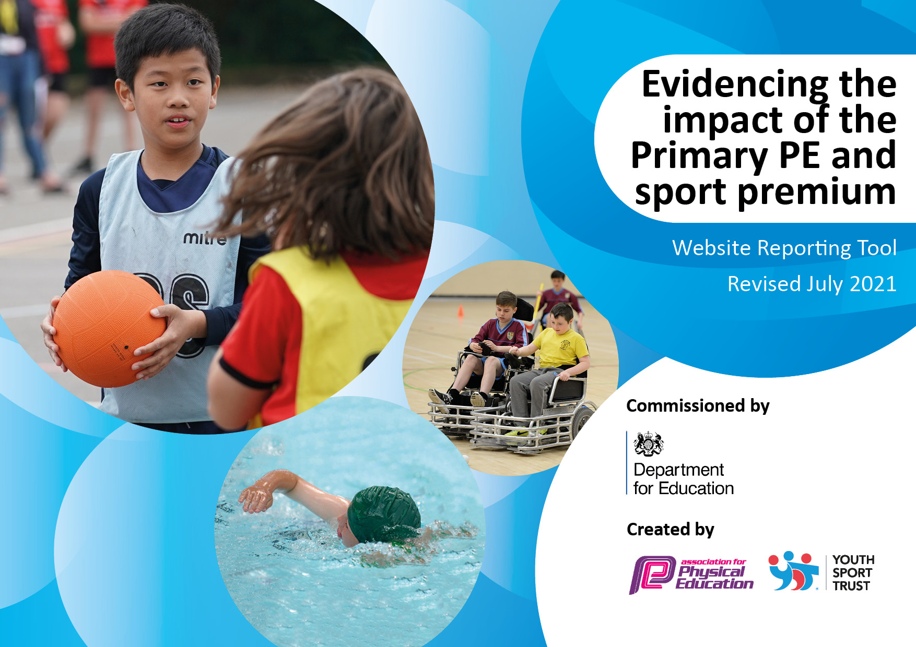

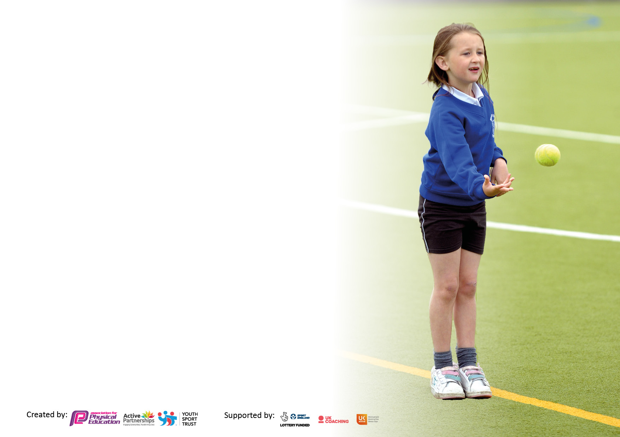

It is important that your grant is used effectively and based on school need. The Education Inspection Framework makes clear there will be a focus on **‘whether leaders and those responsible for governors all understand their respective roles and perform these in a way that enhances the effectiveness of the school’**.

Under the Quality of Education Ofsted inspectors consider:

**Intent** - Curriculum design, coverage and appropriateness

**Implementation** - Curriculum delivery, Teaching (pedagogy) and Assessment

**Impact** - Attainment and progress

To assist schools with common transferable language this template has been developed to utilise the same three headings which should make your plans easily transferable between working documents.

Schools must use the funding to make **additional and sustainable** improvements to the quality of Physical Education, School Sport and Physical Activity (PESSPA) they offer. This means that you should use the Primary PE and sport premium to:

* Develop or add to the PESSPA activities that your school already offer
* Build capacity and capability within the school to ensure that improvements made now will benefit pupils joining the school in future years
* The Primary PE and sport premium should not be used to fund capital spend projects; the school’s budget should fund these.

Pleasevisitgov.ukfortherevisedDfEguidanceincludingthe5keyindicatorsacrosswhichschoolsshoulddemonstrate animprovement.Thisdocumentwillhelpyoutoreviewyourprovisionandtoreportyourspend.DfEencouragesschools to use this template as an effective way of meeting the reporting requirements of the Primary PE and sport premium.

We recommend you start by reflecting on the impact of current provision and reviewing the previous spend.

Schools are required to publish details of how they spend this funding, including any under-spend from 2019/2020, as well as on the impact it has on pupils’ PE and sport participation and attainment. **All funding must be spent by 31st July 2022.**

We recommend regularly updating the table and publishing it on your website throughout the year. This evidences your ongoing self-evaluation of how you are using the funding to secure maximum, sustainable impact. Final copy must be posted on your website by the end of the academic year and no later than the 31st July 2021. To see an example of how to complete the table please click HERE.

Created by: Supported by:

**Details with regard to funding**

Please complete the table below.

|  |  |
| --- | --- |
| Total amount carried over from 2021/22 | £ |
| Total amount allocated for 2022/23 | £18,209 |
|  |  |
| Total spend to date | £17,823.97 |
|  |  |

**Swimming Data**

Please report on your Swimming Data below.

|  |  |
| --- | --- |
| Meeting national curriculum requirements for swimming and water safety.  N.B. Complete this section to your best ability. For example you might have practised safe self-rescue techniques on dry land which you can then transfer to the pool when school swimming restarts.  **Due to exceptional circumstances priority should be given to ensuring that pupils can perform safe self-rescue even if they do not fully meet the first two requirements of the NC programme of study** |  |
| What percentage of your current Year 6 cohort swim competently, confidently and proficiently over a distance of at least 25 metres?  **N.B.** Even though your pupils may swim in another year please report on their attainment on leaving primary school at the end of the summer term 2020.  Please see note above | 11% |
| What percentage of your current Year 6 cohort use a range of strokes effectively [for example, front crawl, backstroke and breaststroke]?  Please see note above | 24% |
| **What percentage of your current Year 6 cohort perform safe self-rescue in different water-based situations?** | 84% |
| Schools can choose to use the Primary PE and sport premium to provide additional provision for swimming but this must be for activity **over and above** the national curriculum requirements. Have you used it in this way? | No ( Due to swimming pools capacity) |

**Action Plan and Budget Tracking**

Capture your intended annual spend against the 5 key indicators. Clarify the success criteria and evidence of impact that you intend to measure to evaluate for pupils today and for the future.

|  |  |  |  |  |
| --- | --- | --- | --- | --- |
| **Academic Year:** 2022/23 | **Total fund allocated:** | **Date Updated:** | |  |
| **Key indicator 1:** The engagement of all pupils in regular physical activity – Chief Medical Officers guidelines recommend that primary school pupils undertake at least 30 minutes of physical activity a day in school | | | | Percentage of total allocation: |
| 48.8% £8,699.50 |
| **Intent** | **Implementation** | | **Impact** |  |
| Your school focus should be clear what you want the pupils to know and be able to do and about  what they need to learn and to  consolidate through practice: | Make sure your actions to achieve are linked to your intentions: | Funding allocated: | de | Sustainability and suggested next steps: |
| Provision for all children to access Forest Schools to build confidence and knowledge in regards to the outdoor curriculum.  Maintaining and developing the outdoor environment to ensure it remains stimulating and gives additional opportunities for physical exercise and team work.  Pupil Voice for either Tennis Table or other larger piece of equipment to enhance the provision outside  Increased lunchtime provision to run sports | Forest School booked for a full day a week for the whole year and timetabled for all classes to receive 6-7 weeks of lessons.  Create a tyre tunnel  Replenish sports equipment, scooters and construction pit equipment.  2 hours a week £ 13 an hour x 39 | £ 4580  September to July  Cost of labour  Cost of equipment/ resources. £400  Scooters £205.50 each  Construction equipment  £300  £2,200  £1014 | All children in school ( Reception to Year 6 ) have received a minimum of 12 hours of Forest Schools educations. Most have received more than this.  Children e developed their team work skills, resilience and outdoor skills e.g making their own fire, den.  Tyre Tunnel is constructed and well used.  Additional scooters and construction equipment has been purchased. Scooters are very popular and used well as is the construction pit.  Increased staffing has improved access and use of the outdoor resources. | To continue with Forest Schools using the same provider.  To have team building games as part of the PE curriculum to sustain and develop skills.  Purchase additional scooters as promoting good aerobic exercise.  To employ a lunchtime leader to develop and lead on the implementation of outdoor games. |
| **Key indicator 2: The profile of PE and sport is raised across the school as a tool for whole school improvement** | | | | Percentage of total allocation: |
| 6.03% £1074.47 |
| **Intent** | **Implementation** | | **Impact** |  |
| Your school focus should be clear what you want the pupils to know and be able to do and about  what they need to learn and to  consolidate through practice: | Make sure your actions to achieve are linked to your intentions: | Funding allocated: | Evidence of impact: what do pupils now know and what can they now do? What has changed?: | Sustainability and suggested next steps: |
| PE sports award termly to raise the value of PE  Tennis nets to be purchased to improve the teaching of tennis across school  Hockey goals to be purchased and hockey sticks. | All staff to nominate a child termly award board to celebrate their achievements.  Medals as prizes  Nets ordered, practice nets and long net for lesson teaching | £100  Tennis nets  £220  Tennis Balls  £200  Hockey Sticks  £109.95 x 4  Hockey Goals  £114.67 | Profile of sports has been raised and children’s understanding of what skills are need to be an athlete.  Tennis coach developed the use further with two classes receiving specialist tennis coaching that also provided CPD for staff.  Tennis is taught as a sports unit.  Hockey sticks purchased which has allowed the sport to be played at break and lunch as well.  Hocker goals were not purchased. | To continue  Develop to have sports leaders at lunch and playtime- led by lunchtime lead.  Tennis coaching to continue next year for two classes.  To role out further is a cost of £25 an hour.  Purchase Hockey Goals – Contact Hockey club to see if any specialist coaching available. |

|  |  |  |  |  |
| --- | --- | --- | --- | --- |
| **Key indicator 3:** Increased confidence, knowledge and skills of all staff in teaching PE and sport | | | | Percentage of total allocation: |
| 6% £ 1070 |
| **Intent** | **Implementation** | | **Impact** |  |
| Your school focus should be clear | Make sure your actions to | Funding | Evidence of impact: what do | Sustainability and suggested |
| what you want the pupils to know | achieve are linked to your | allocated: | pupils now know and what | next steps: |
| and be able to do and about | intentions: |  | can they now do? What has |  |
| what they need to learn and to |  |  | changed?: |  |
| consolidate through practice: |  |  |  |  |
| Subscription to PE Hub to continue with the planned curriculum and have access to training videos.  Dance CPD for teachers using the scheme  PE Conference training for Sports Leader  Assessment Tool | Cost of scheme PE Hub  <https://thepehub.co.uk/>  Source a trainer  West Yorkshire Sports  Research and source appropriate resource | £500  £300  £70  £200 | Staff confidence has improved and consistency of teaching is better  .  Unable to source an external trainer. Some internal from a dance teacher on the staff.  Conference attaneded.  Looking at a new scheme that has assessment as part of the package. | Review the scheme and the curriculum overview to accommodate the vertically grouped classes as this has been an area of difficulty this year.  Still an are of reduced staff confidence. New scheme to be sourced that provides greater support.  Wakefield Trust to look at assessment of foundations subjects.  Scheme to research. |
| **Key indicator 4:** Broader experience of a range of sports and activities offered to all pupils | | | | Percentage of total allocation: |
| 34.9% £6220 |
| **Intent** | **Implementation** | | **Impact** |  |
| Your school focus should be clear | Make sure your actions to | Funding | Evidence of impact: what do | Sustainability and suggested |
| what you want the pupils to know | achieve are linked to your | allocated: | pupils now know and what | next steps: |
| and be able to do and about | intentions: |  | can they now do? What has |  |
| what they need to learn and to |  |  | changed? |  |
| consolidate through practice: |  |  |  |  |
| Additional achievements:  Clubs –  Hockey  Pro football  Forest Schools  Residential trip to Kingswood for outdoor adventure activities  Subsidised places  Subsidised camping places for Year 6 | Contact providers  Arrange clubs across the year with providers and with staff.  Monitor attendance  Forest School booked for a full day a week for the whole year and timetabled for all classes to receive 6-7 weeks of lessons  Overnight camping for Years 6 Booked through Forest Schools | Football £1,560  Forest School £2,660  £1,000  £1,000 | Children challenged outside of their normal experiences. Including staying away from home overnight which for many was the first time.  30 children attended. Team building games played. Fire making, outdoor cooking. Camp maintenance. Tent management including decamping  Included five pupils with EHCP( additional SEND need) | Sports based clubs to continue to be subsidised.  Source some different ones following from pupil voice ( archery)  Forest school club to continue as this is very popular. |

|  |  |  |  |  |
| --- | --- | --- | --- | --- |
| **Key indicator 5:** Increased participation in competitive sport | | | | Percentage of total allocation: |
| 4.27% £760 |
| **Intent** | **Implementation** | | **Impact** |  |
| Your school focus should be clear | Make sure your actions to | Funding | Evidence of impact: what do | Sustainability and suggested |
| what you want the pupils to know | achieve are linked to your | allocated: | pupils now know and what | next steps: |
| and be able to do and about | intentions: |  | can they now do? What has |  |
| what they need to learn and to |  |  | Changed? |  |
| consolidate through practice: |  |  |  |  |
| West Yorkshire Disability Athletics ( If it runs this year )  Competitive Sports Day | Book places and meet with parents.  Organise staffing and training for pupils taking part.  PE lead to organise a sports day with competitive element. Trophies and Medals.  Football goals  ( second set) | Transport Costs  £250  Entrance Fees  £60  Staffing£50  Prizes- £100  Goals £300 | This did not take place. The timings of the event were not suitable for us to access.  Sports Days were held and were competitive. However due to bad weather one had reduced number of races and one was cancelled | To look for other opportunities for competitive sports. |

|  |  |
| --- | --- |
| Review Signed off by | |
| Head Teacher: | Lorna Kemplay |
| Date: | 24/07/23 |
| Subject Leader: | Ella Atkinson |
| Date: | 24/07/23 |
| Governor: | Neil Hardwick |
| Date: | 10/23 ( Next full governors) |