Entry 1: Year 6- Rahaf, Age 11 ‘United’
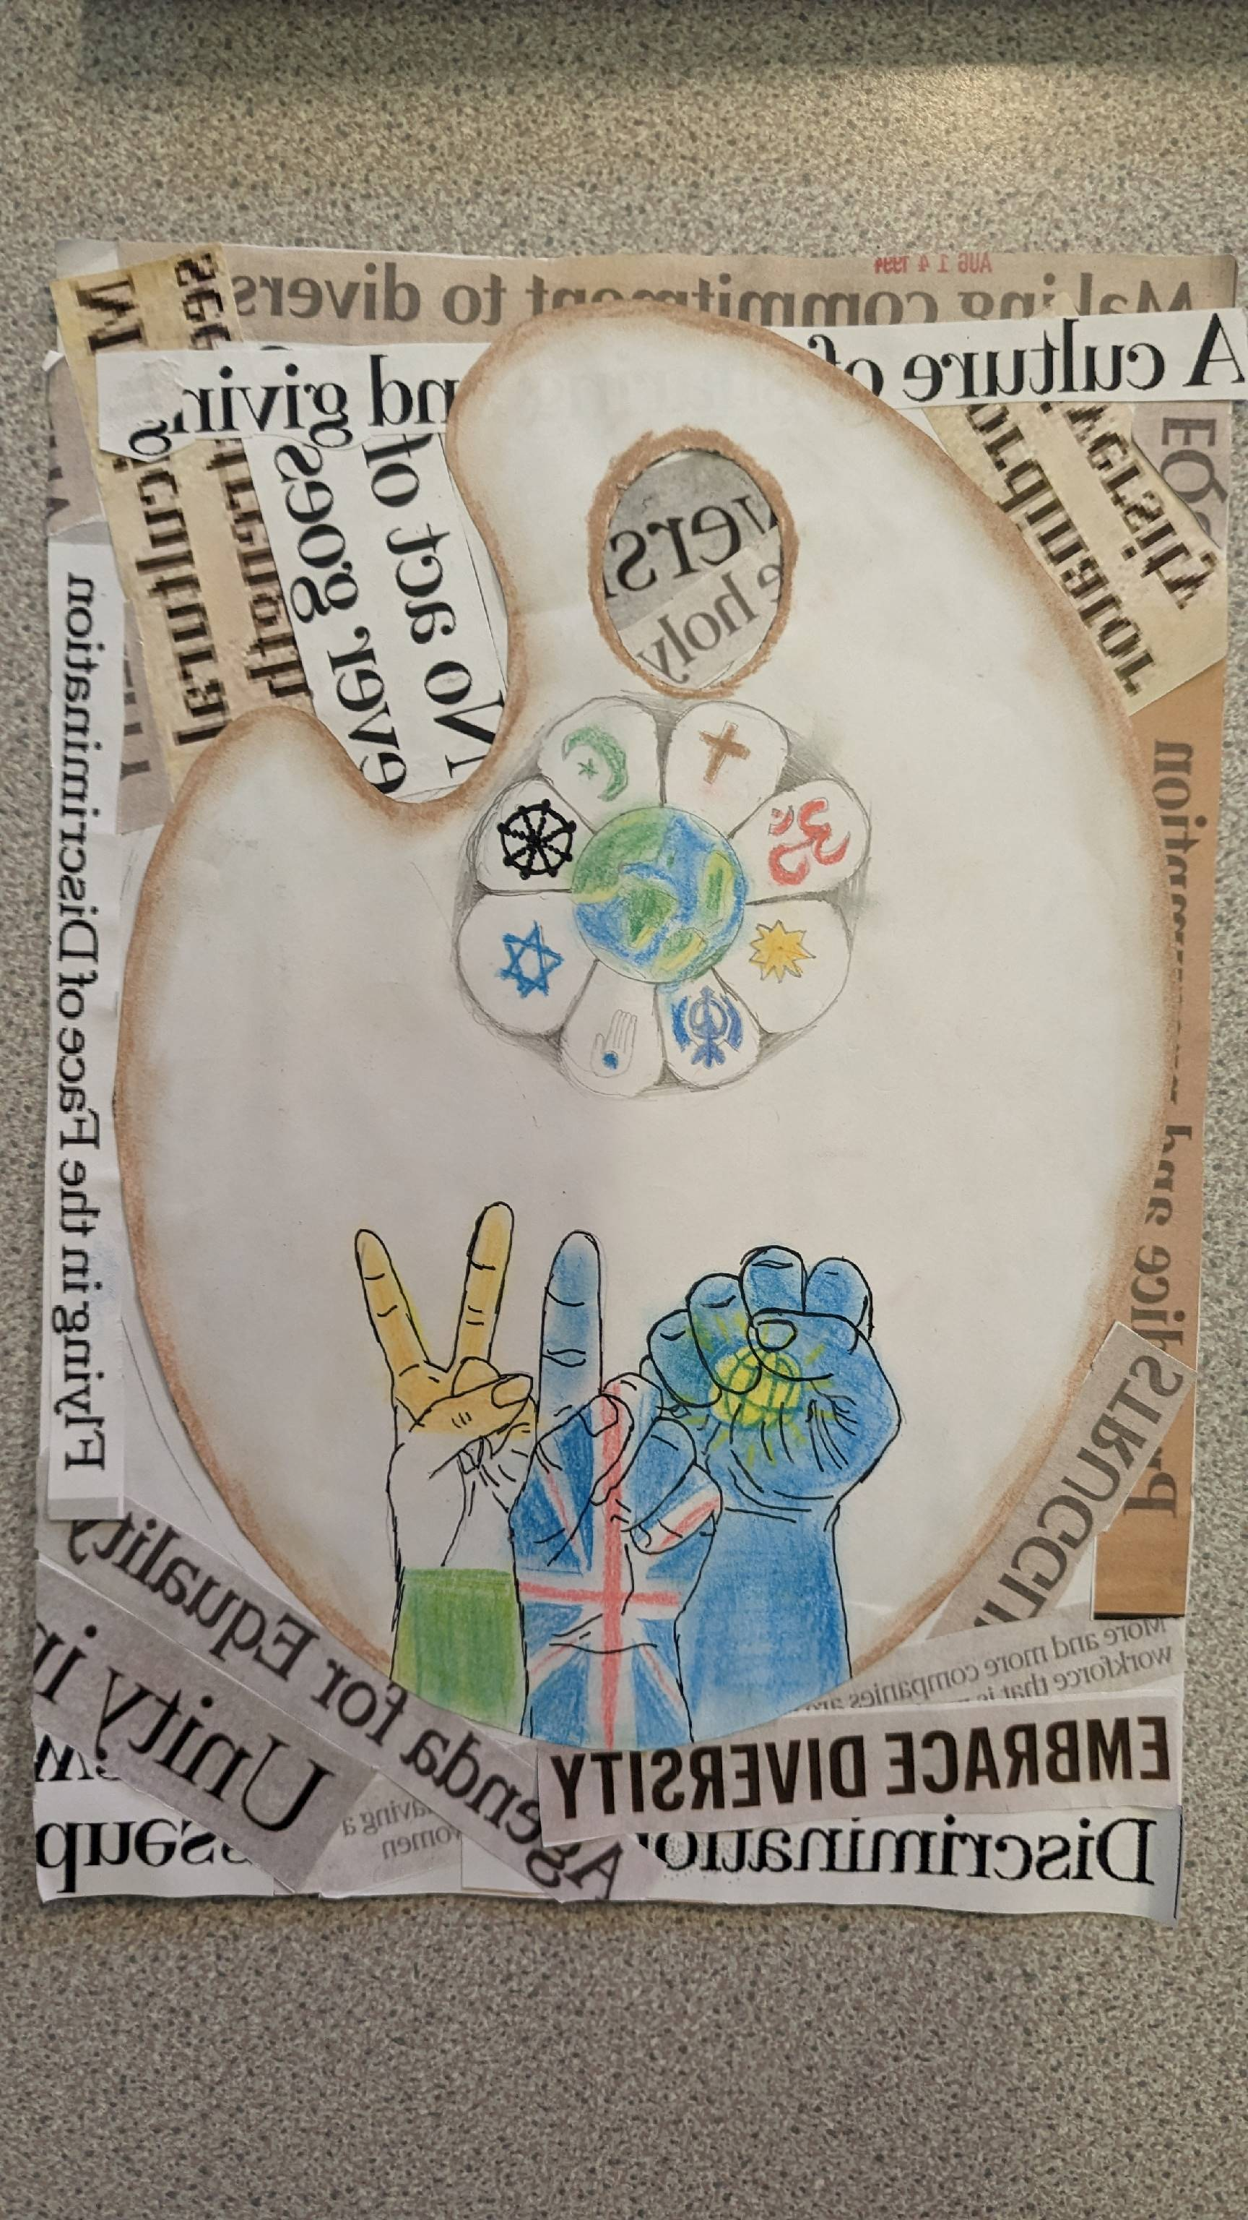
“In my artwork, the flower represents all the different religions that make up the world. The hands represent the different nations, the commonwealth- two countries within the commonwealth that are different but united. The quote to me means that even though we all different and unique, we have some much in common- in our class we all love to play games and spend time with each other. We don’t even think about the colour of our friends’ skin, their background or their religion.”

Entry 2: Year 5.6- Amina, 10 ‘Flags’
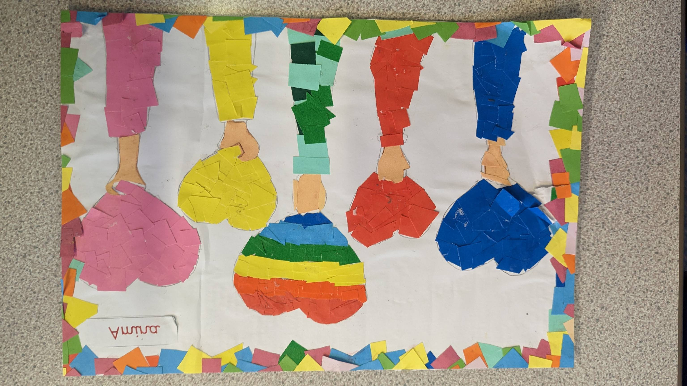

“In my artwork, the multi-coloured flag represents the pride flag, love, the yellow flag represents happiness, the pink flag represents cancer research, and the blue and final flag represents nature and the world. I was inspired by the quote as I think we should all be treated equally and treat others equally- no one is better than anyone else because we are all humans at the end of the day.”

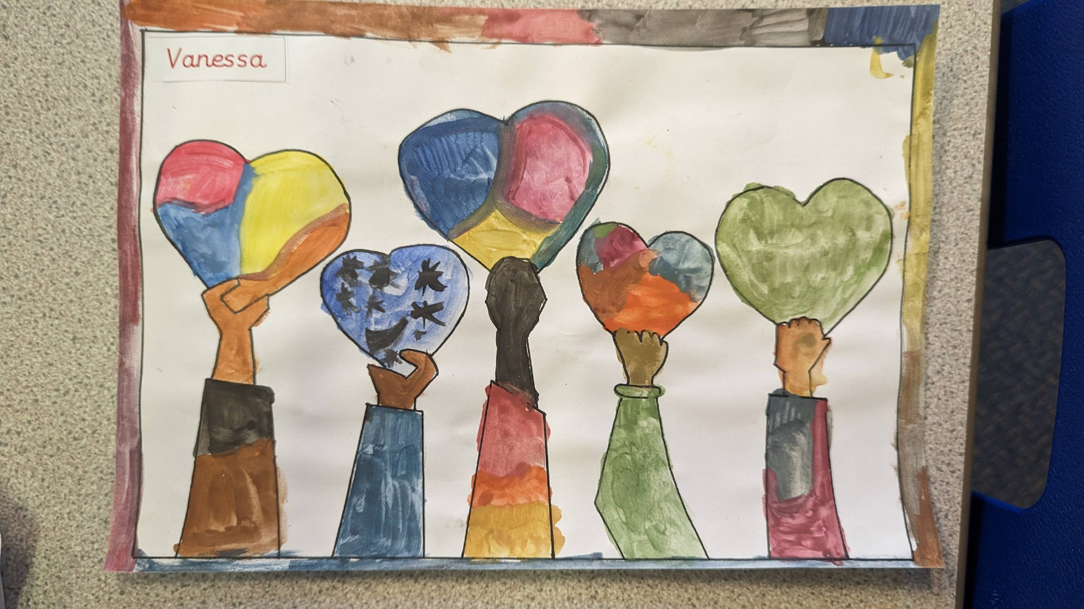Entry 3: Year 5.6- Vanesa, 9 ‘Flags’

“We discussed the things about humans that make us all the same as well as the things that may make us appear different to one and other. I felt that it was really important to celebrate individual differences whilst recognising that we are all the same on the inside.”

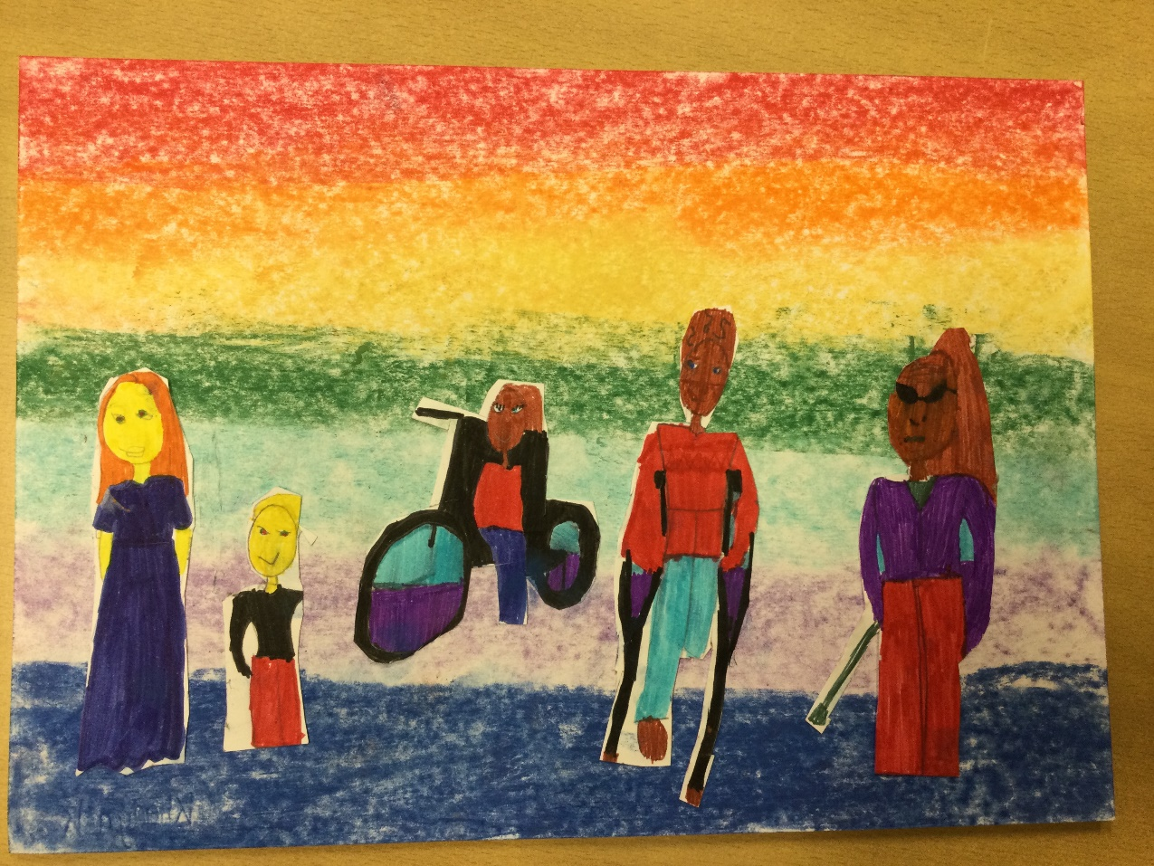
Entry 4: Year 3.4 – Khadija, age 9 ‘Diversity’

“I used pastels and chalk to design a rainbow background for my artwork which represents diversity in the world that I am growing up into. I have drawn different people to show that every person in this world is different and unique, but that is what makes us special.”

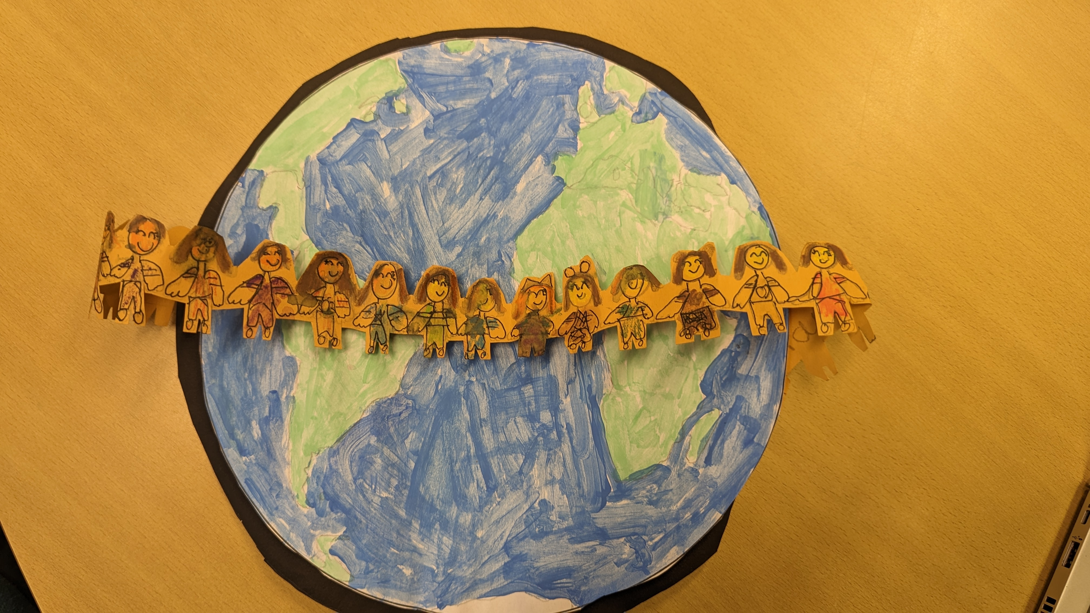Entry 5: Year 4- Shanzay, 9 ‘Stronger Together’

“My artwork represents that everybody in the whole world is equal. Everyone is together and it doesn’t matter what race we are. What really matters is how we treat one and other. I used a paperchain to represent being stronger together and I was inspired by the globe on my school logo.”

Entry 6: Year 3- Ellie age 7 ‘United’
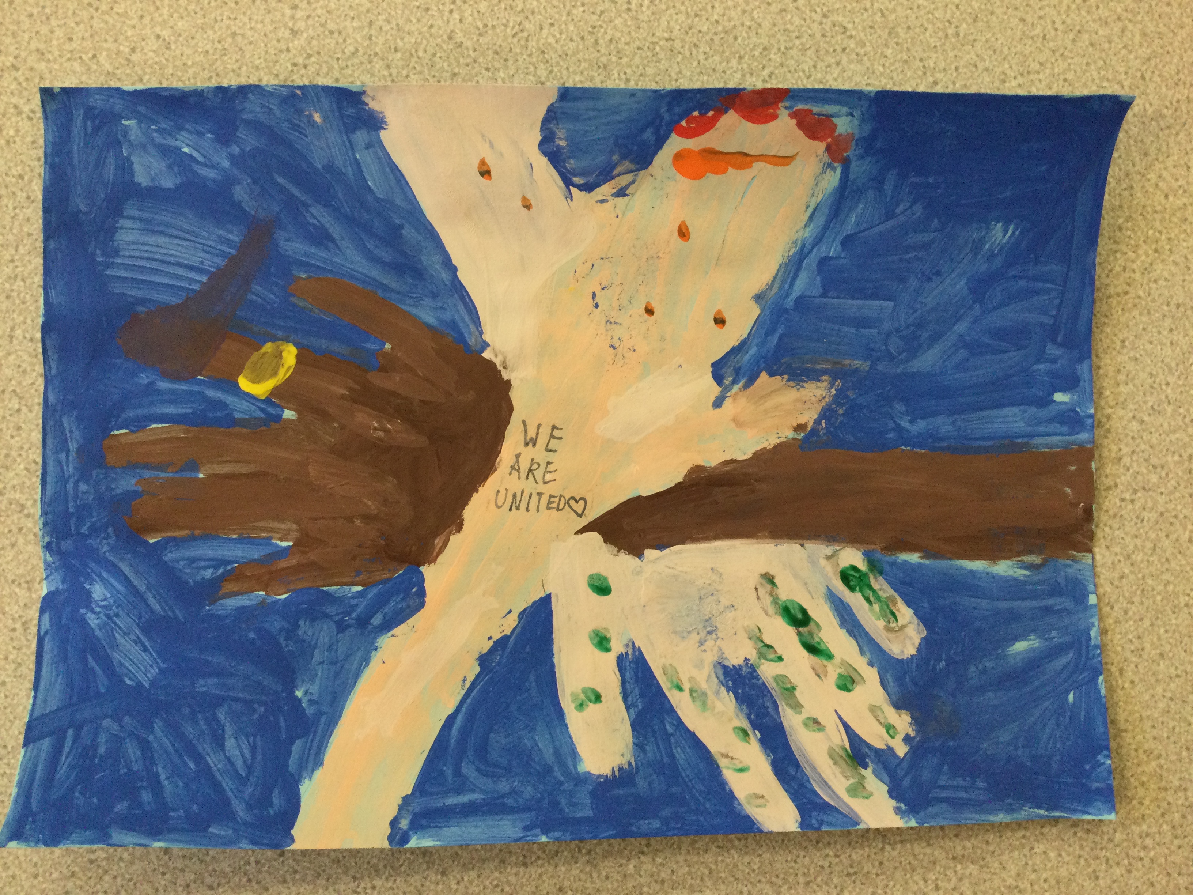

“We all may look different but we all still the same. Everyone in my class is unique because we all have different beliefs, different appearances and different likes and dislikes but we are all friends learning together. It’s what’s on the inside the counts the most, especially kindness.”

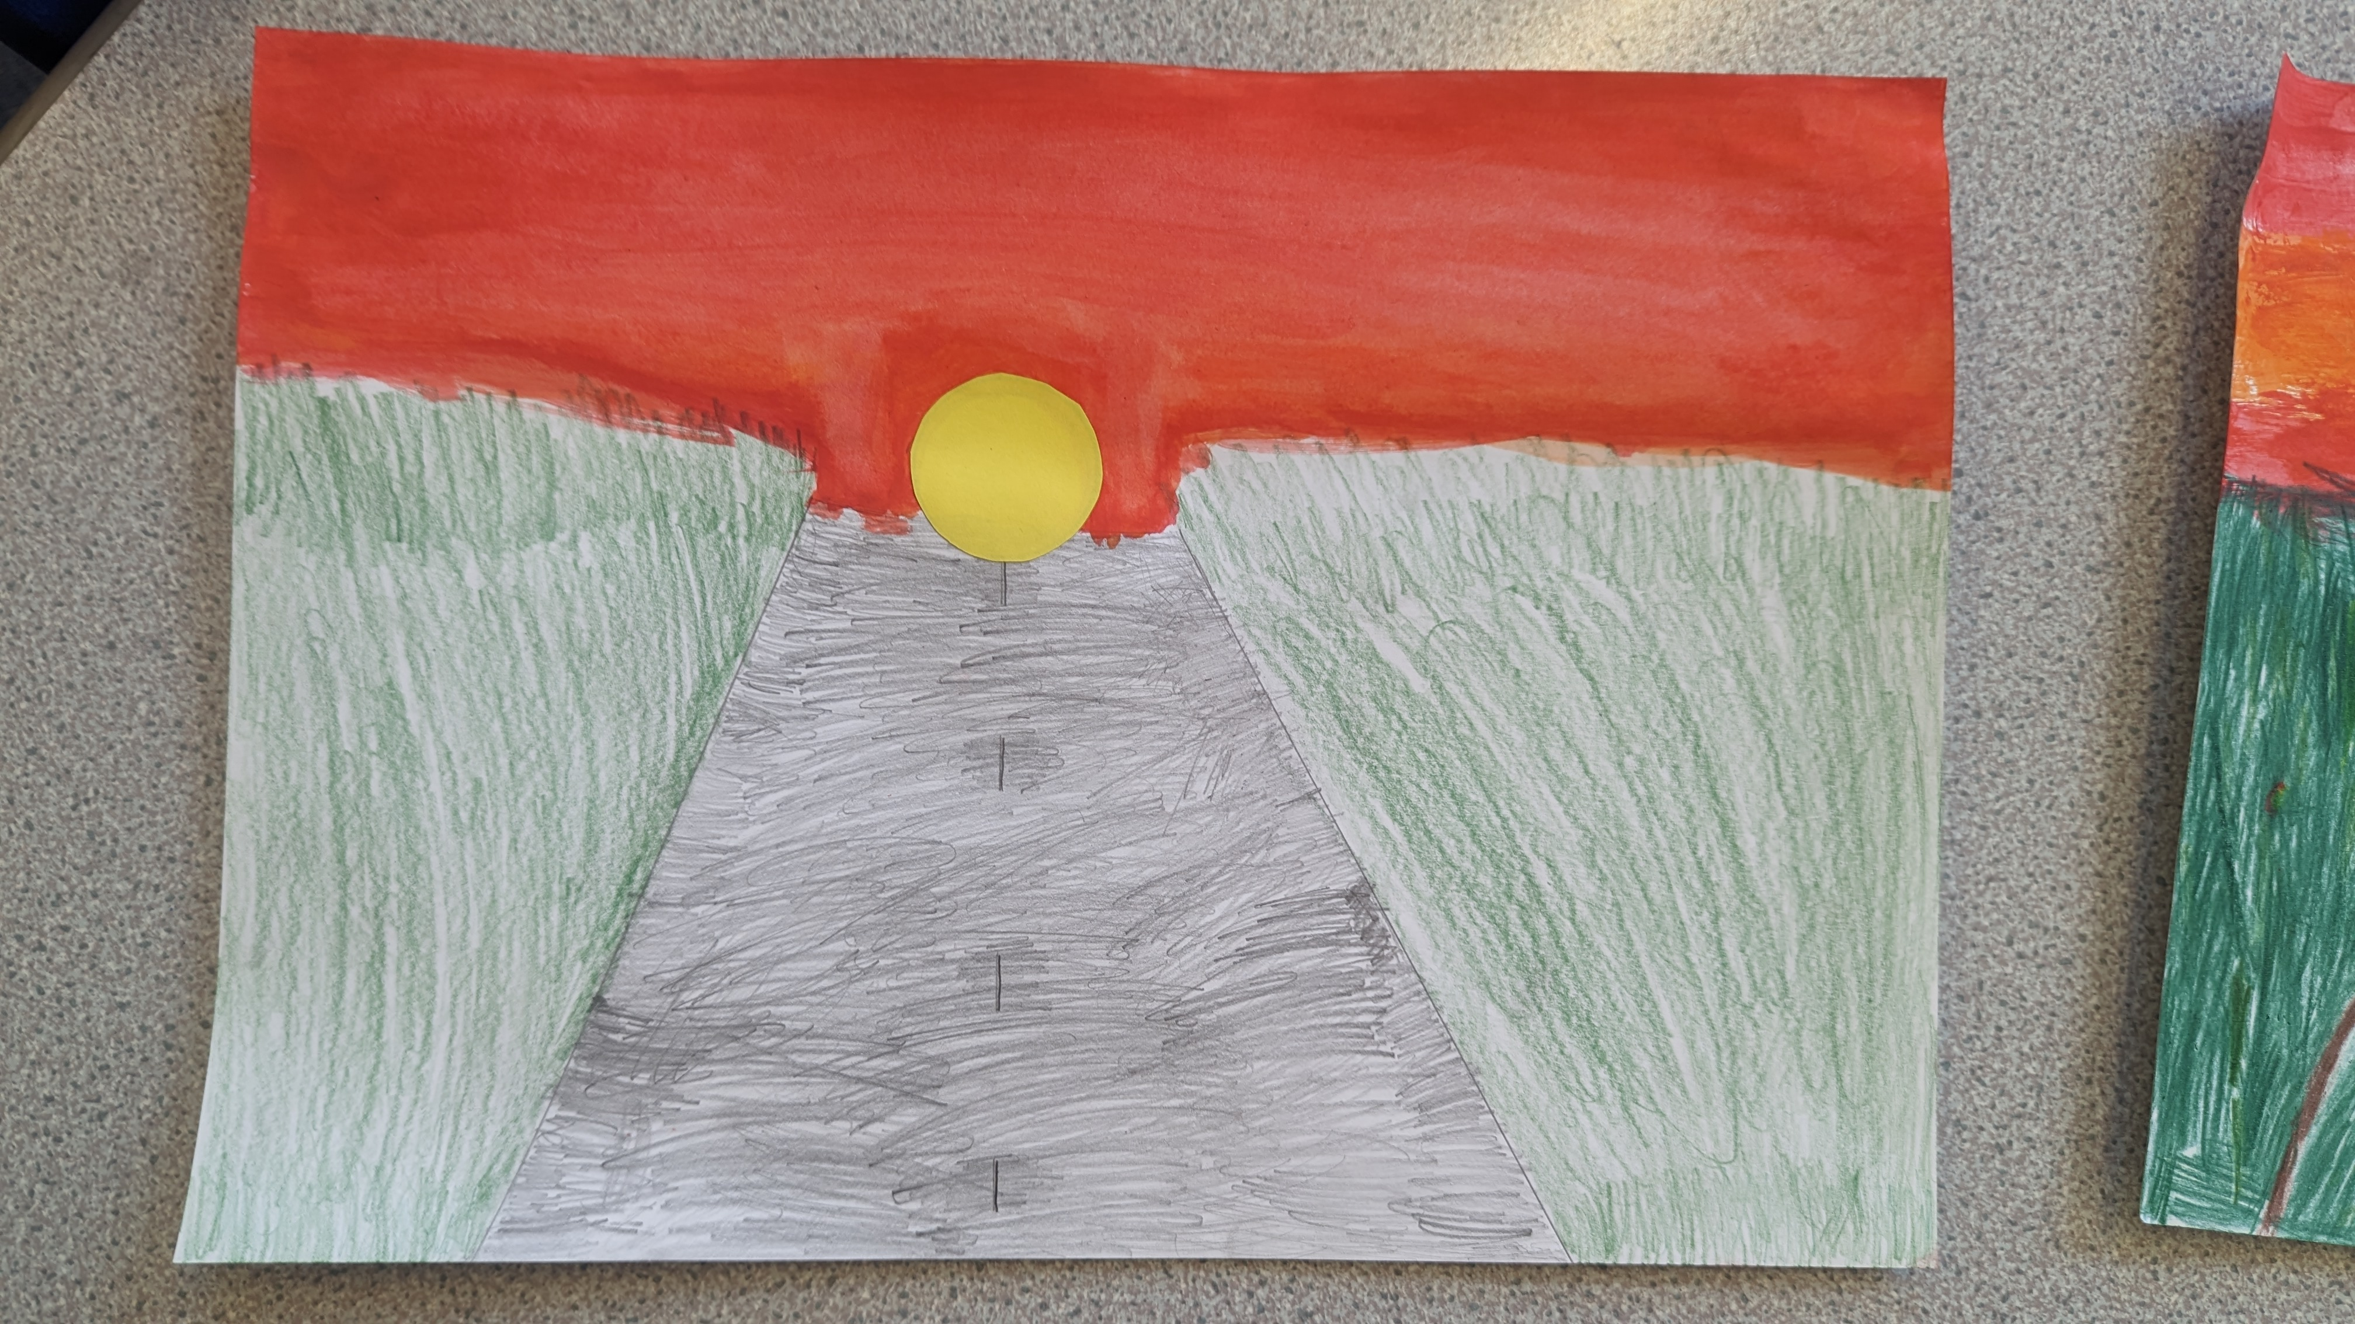Entry 7: Year 2- Isabella age 7 ‘Life is a Journey’

“Life is a journey- we have similarities and differences along with a different vision of where we want our life journey to take us. With my peers, I spent a long time realising that our journeys are similar despite our differences such as religion, races, gender and age. I am a Muslim and I hope that my journey through life will lead to me becoming a successful dentist.”

Entry 8: Year 1.2- River age 6 ‘Portraits’
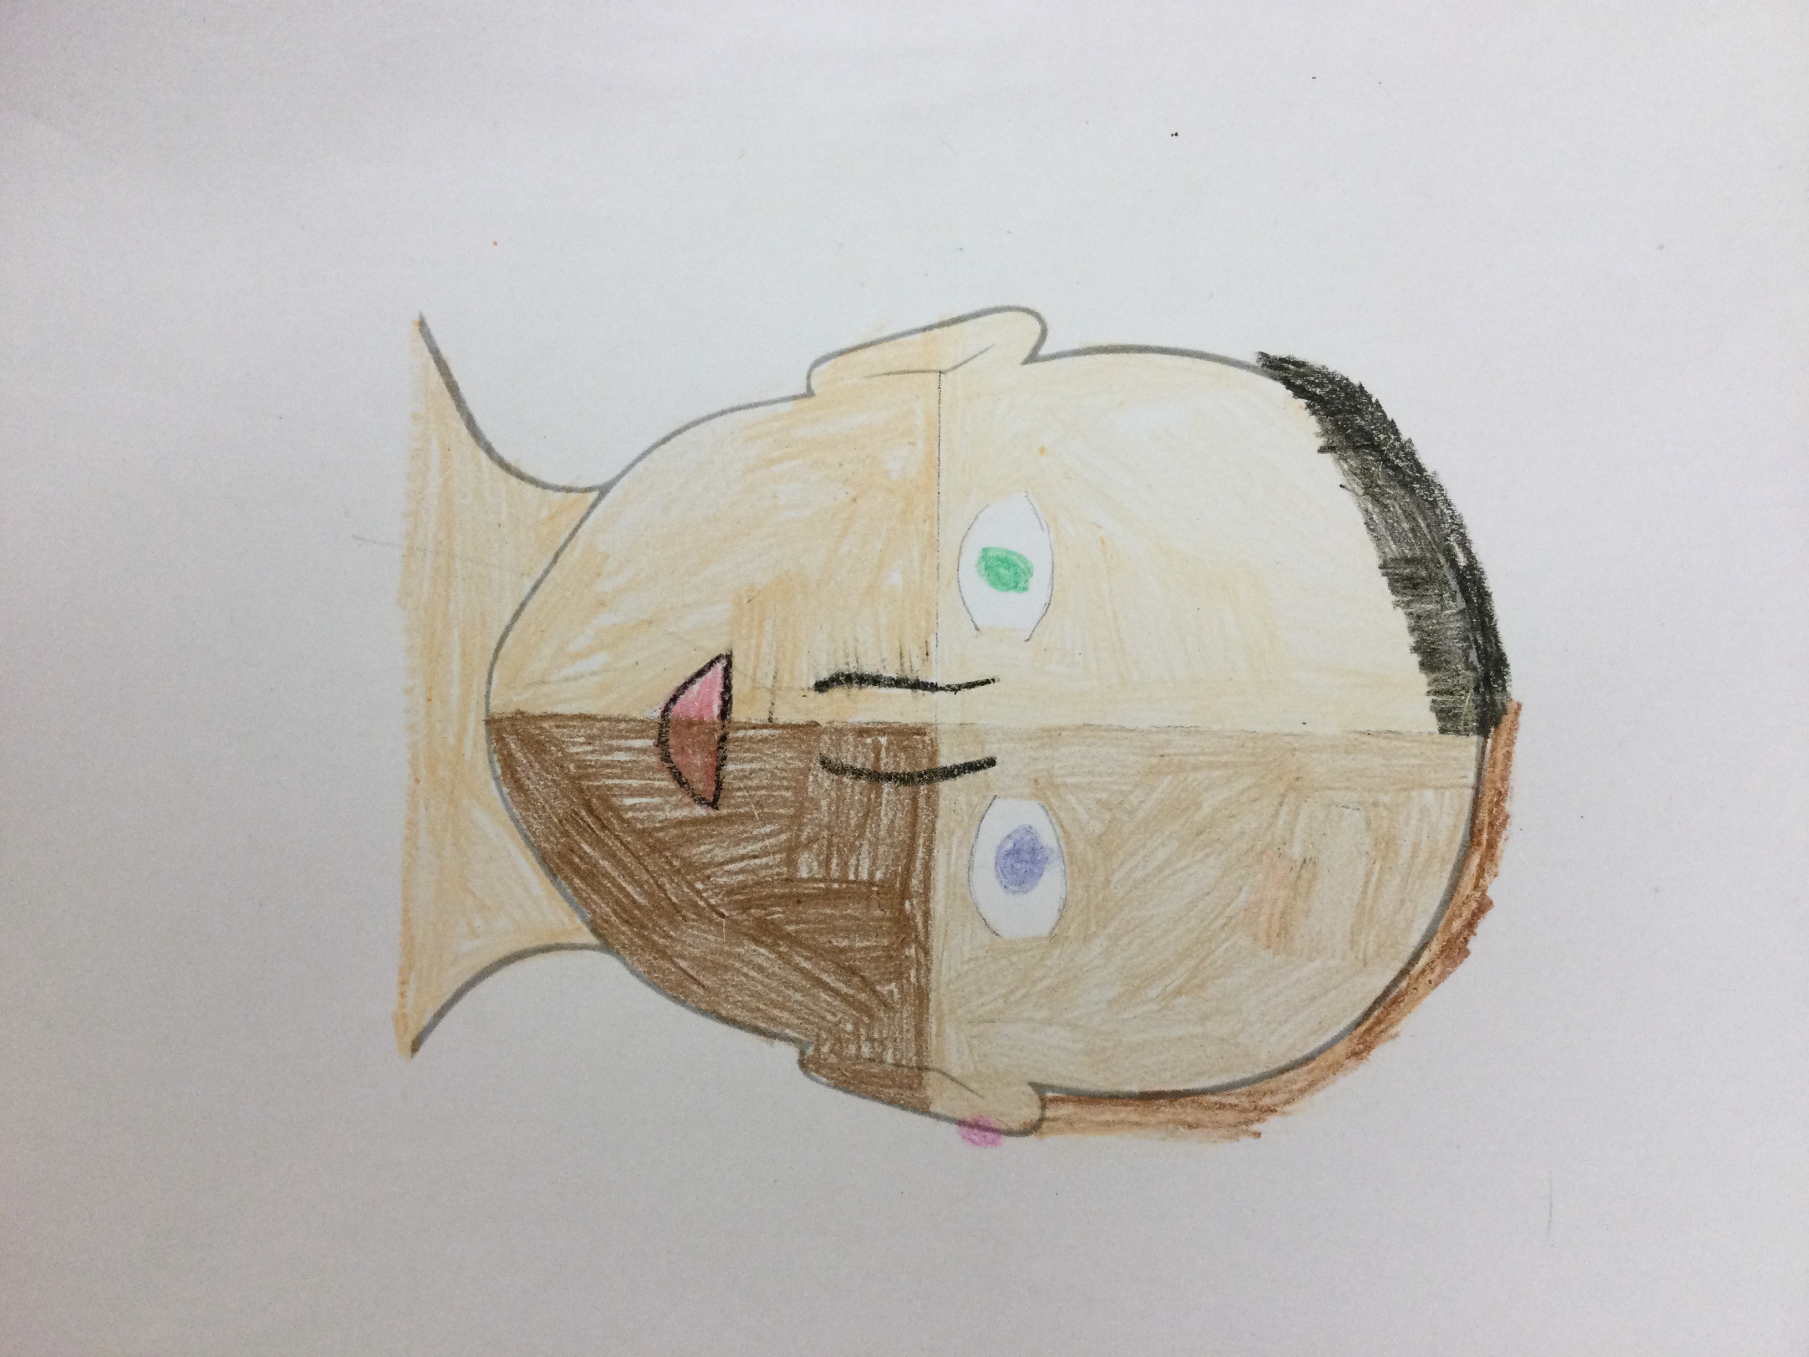

“With my peers, I understand that we are all different in appearance, beliefs, likes and dislikes but we are all still equal. We are all unique because of our differences, but we are also all deserving of the same things in life.”

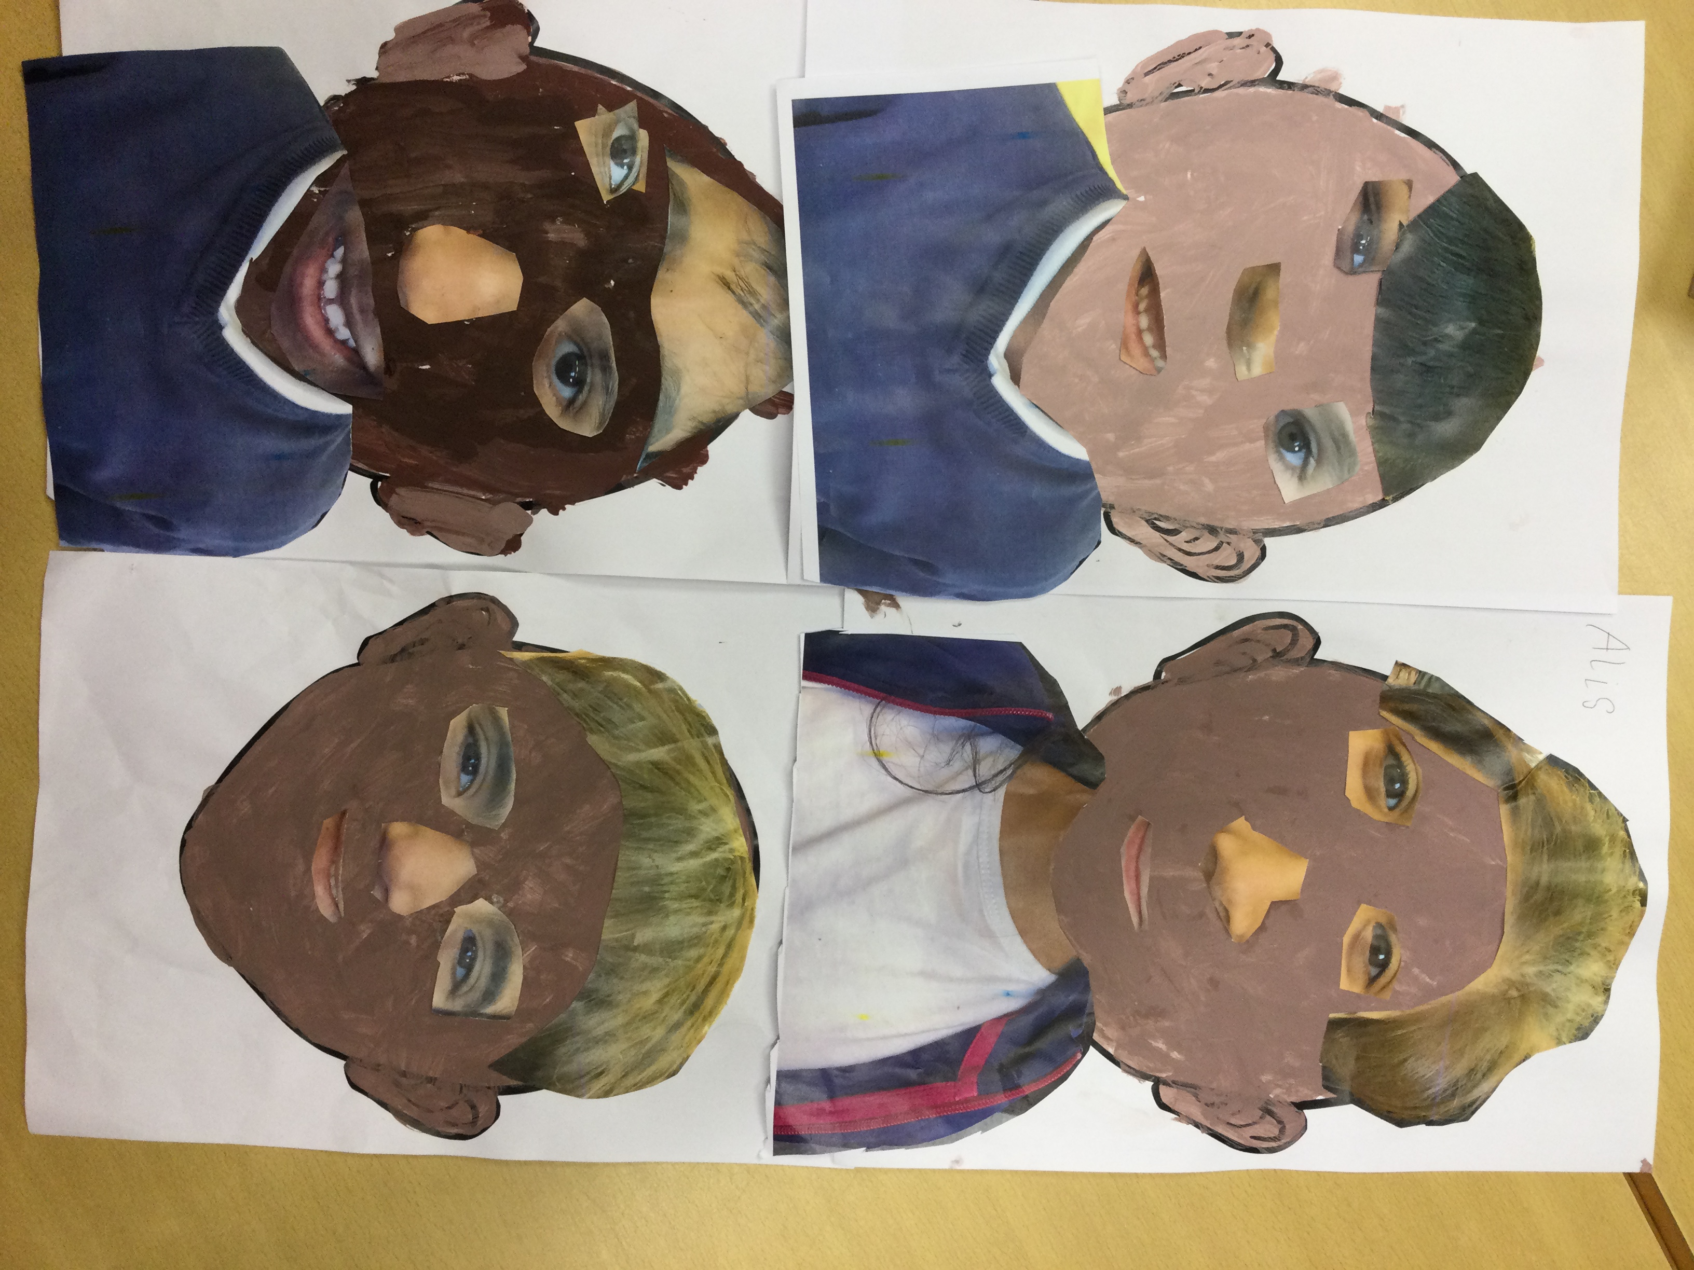Entry 9: Year 1- Milan age 6, Inayah age 6, Leo age 5 and Eleana age 5 ‘Friends in our Class’

“We used different parts of our peers faces to create our own pieces of art work. We think that this represents how different and unique we all are but how we are all friends learning together.”

Entry 10: Nursery Mustafa age 3, Aaisha age 4, Inaaya age 4 ‘Elephants’
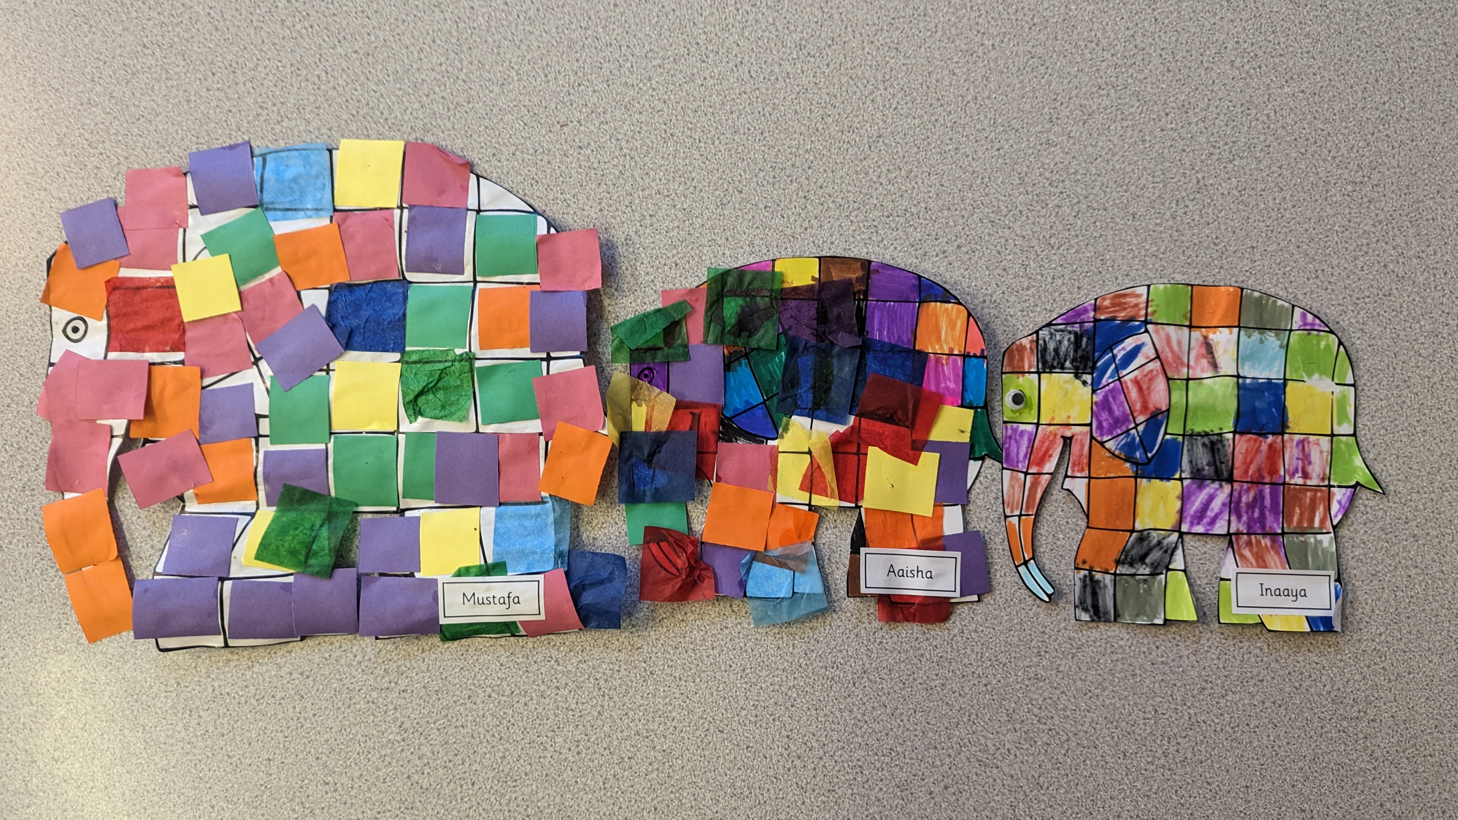
“Together, we read the story ‘Elmer’ and we looked at the similarities and differences that we have with each other. In our class, we have lots of friends that belong to a different religion, race or ethnic background but we are all friends learning together. We independently decided how to make our Elmer to represent how unique we are.”

