
Reading Policy
January 2023
This document aims to show the school’s reading ethos and how it is practised through discretely taught Teaching of Reading sessions as well as other areas across the school and curriculum. It will set out a series of expectations for teachers, providing clarity for all members of staff to ensure that all our pupils are provided with a rich and varied learning experience that aims develops the children as lifelong readers. Through the curriculum and our practice we strive to develop a culture of reading through consistently using high quality texts, that demonstrate aspirational language and grammatical structure; a variety of texts that inspire and enthuse children; texts with themes that help our children to develop and promote the school’s values as well as ensuring their personal, social, spiritual and emotion needs are met and where children are able to progress and reach their full potential.

Table of Policy Content:

- Reading at Pinders primary School

- Pinders Culture of Reading

- Pinders Book Corners

- Home School Reading & involvement of Parents/carers role

- What does the teaching of reading look like at Pinders?

- Our reading scheme

- Reading Assessment

- At a Glance – The Non-negotiables

Reading at Pinders Primary School

As our school, we believe that creating a culture of reading is a vital tool in ensuring our children
are given the best life chances. Cultivating readers with a passion for a wide range of materials
will ensure that children’s love of reading will extend far beyond the classroom and allow them to build on their skills independently through a real curiosity and thirst for knowledge. Through our discussions and research, we believe that the following principles are at the forefront of our approach to reading.

- Reading is challenging
We develop our understanding and command of the English language through our experience of and exposure to challenging texts
- Reading is varied
We recognise that reading comes in many forms and is essential to everyday life
- Reading is explored
We use ‘close reading’ to interrogate texts through rigorous study
- Reading is inspirational
We are enthused and stimulated by what we read and use the ideas and techniques
that we have experienced when reading to inform our own written work

The pillars of reading at Pinders Primary School
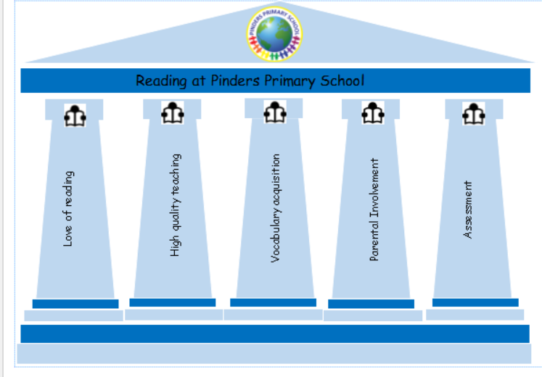

Most of us read without even thinking about it. It’s a skill we take for granted, yet one that is essential for being able to get on in life. As a child grows up, being able to read well, not only enables them to discover new facts and to learn at school, but also opens them up to a world of new ideas, stories and opportunities. The importance of English has never been greater. To be literate is to be on the pathway to becoming a lifelong learner; it is difficult, if not impossible, to reach one’s potential without being able to read.

Stories allow us to define our world and discover our place in it. They help us understand the world we live in, teach us about where we come from, and help us to see our possible futures. It is our priority that our children are immersed in reading and leave Pinders Primary School as competent readers.

The reading pillars at Pinders Primary School are how we instil these essential reading skills in the children we have the good fortune to teach, aiming to give every child the skills they need for the next stage in their education and for life.

A Culture of Reading at Pinders

Developing a culture of reading at Pinders is fundamental to progress and outcomes of our children in all subjects. In classrooms, teachers place a high value on books and reading by;

- Ensuring that the classroom has a well-designed and looked after book corner linked to their class author theme.
- Caring for books through the use of school and class librarians.
- Finding daily opportunities for children to read independently.
- Ensuring daily reading aloud of aspirational and engaging texts.
- Finding regular opportunities for the children to listen to an adult reading (DEAL- Drop everything and listen sessions).
- Additional events and activities to enhance understanding and enjoyment:
- Trips to Wakefield Library
- Weekly visits to the School Library
- Access to the Outdoor Community Library after school and at breaktimes
- Visits from authors/poets/illustrators
- Trips to theatre productions linked to books
- An annual Book Week that celebrates reading
- An annual Poetry week that celebrates poetry
- Prizes and awards to celebrate reading success
- Weekly Reader of the Week awards
- Termly Star Reader awards in each class

Book Corners at Pinders

Book corners are a staple of every classroom at Pinders Primary School and will be linked to a class reading theme, book or author. Teachers are expected to organise their book corners at the start of the year and maintain and enhance them with the help of the children.

Book corners should contain the following:
- A range of age-related texts (with options that will stretch and challenge as well as some texts that can be accessed by lower ability readers).
- A comfortable space for children to sit and read – this could involve soft seating, cushions, beanbags, rugs etc.
- Key questions that children can think about when they are reading independently.
- Child created books to be added to throughout the year (if appropriate).
- An organised, age-appropriate system for the storage of books.
- Reading gems displayed clearly within each book area.
- A selection of Silver and Gold books that the class have achieved.

Home School Reading & Involvement of parents/carers

Developing strong links between home and school reading is vital in ensuring children at Pinders become lifelong readers. The school will support parental engagement with their child’s reading by
ensuring that appropriate texts are sent home regularly for both independent reading and books to be read aloud.
Expectations of parents/carers
The school recognises that some days are special days for various reasons eg Christmas,
birthdays, holidays, but stresses that these should be the exception and that for a child to
learn to read they should ideally be practising their reading daily, whether at school or not. School will ensure that all children practise reading daily; parents need to do the same as part of their responsibility to ensure their child develops as a learner. The school sets a target for ALL children to read at least four times a week at home. If the class reach 80% or more they are rewarded as a whole class.

Reading at home
School will provide a reading book with the expectation that parents will either read it with
their child, listen to their child or oversee their child reading it as appropriate. An adult should sign, date and note down the page numbers read in the child’s reading diary each time the child reads at home.
As an approximate guide children should be reading for these lengths of time daily:
- Reception, Year 1 and Year 2: 10 minutes with an adult
- Year 3 and 4: 15 minutes, usually with an adult. More fluent readers may read independently but this should be overseen by an adult. Adults play an important role in inspiring reading choices and in engaging children in conversations about their books.
- Year 5 and 6: 20 minutes, mostly independently and with an adult at least twice a week. Adults play an important role in inspiring reading choices and in engaging children in conversations about their books.

Communication with parents/carers
Each child has a reading record. It allows parents/carers to record positive comments to encourage their child, and to make a note of words children had difficulty reading or understanding. When children read to adults in school, these comments and notes will be referred to and will provide useful information to teachers in planning
children’s next steps in reading.

Changing of home reading books
Independent home reading books are changed in the following ways in each year group:
- Reception –the class teacher and LSAs reads 1:1 with individual children and changes their books in line with their reading ability.
Key stage 1 and 2 - the class teacher and LSAs reads 1:1 with individual children and changes their books in line with their reading ability.
- Free readers in each year group - During the day children are given time to change their reading books from a selection of age appropriate and levelled texts.

What does the teaching of reading look like at Pinders?

In order to develop an effective reading curriculum, we have ensured that the various strands (Read and Respond, Cracking Comprehension, Phonics and Spelling, daily reading with a teacher etc.) respond to crucial elements of educational research and theory behind reading development.

We understand that a skills model is very important because by teaching a sequence of skills, separately defined in a logical and sequential order, improves comprehension of texts. Certain elements of our curriculum offer this vital opportunity to our children to allow them to understand the meaning of words by building on sounds and letters and whole words so that they can be related to other words in a sentence. However, other elements of our reading curriculum follow a psycholinguistic model. This is where we encourage and support children in predicting the meaning of words and texts based upon their prior knowledge and experience. We understand that often children need to build upon their own store of information about how language works in order to make sense out of what they are reading and to get meaning. We believe strongly in offering children as many experiences as possible to build on and develop their existing stores of information through rich reading opportunities in school.

We don’t teach these skills in isolation- each part of our reading curriculum nourishes another to provide a rich and broad reading life for all of our children.

Reading Gems - Make reading skills explicit and simple
Each reading skills has an image and a colour associated with it so that children can make those links and, as they become confident in understanding each reading skill, they can identify which skills to use. The reading gems are statements that break down the approach to reading into aspects in which children should become skilled. They will help to ensure that our children develop a clear understanding of the different aspects of reading.

EYFS & Key Stage 1 Reading Gems:
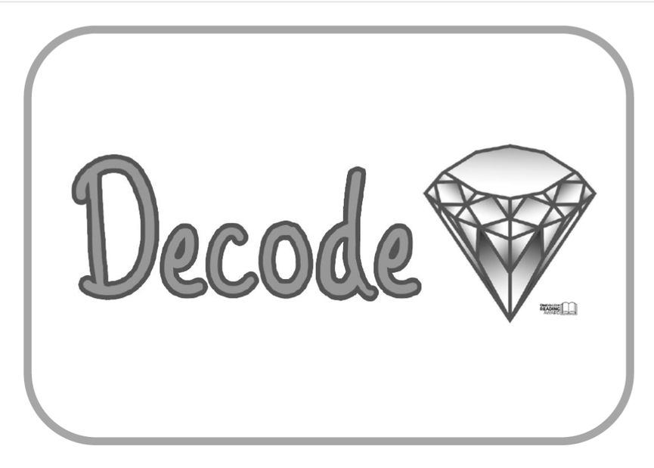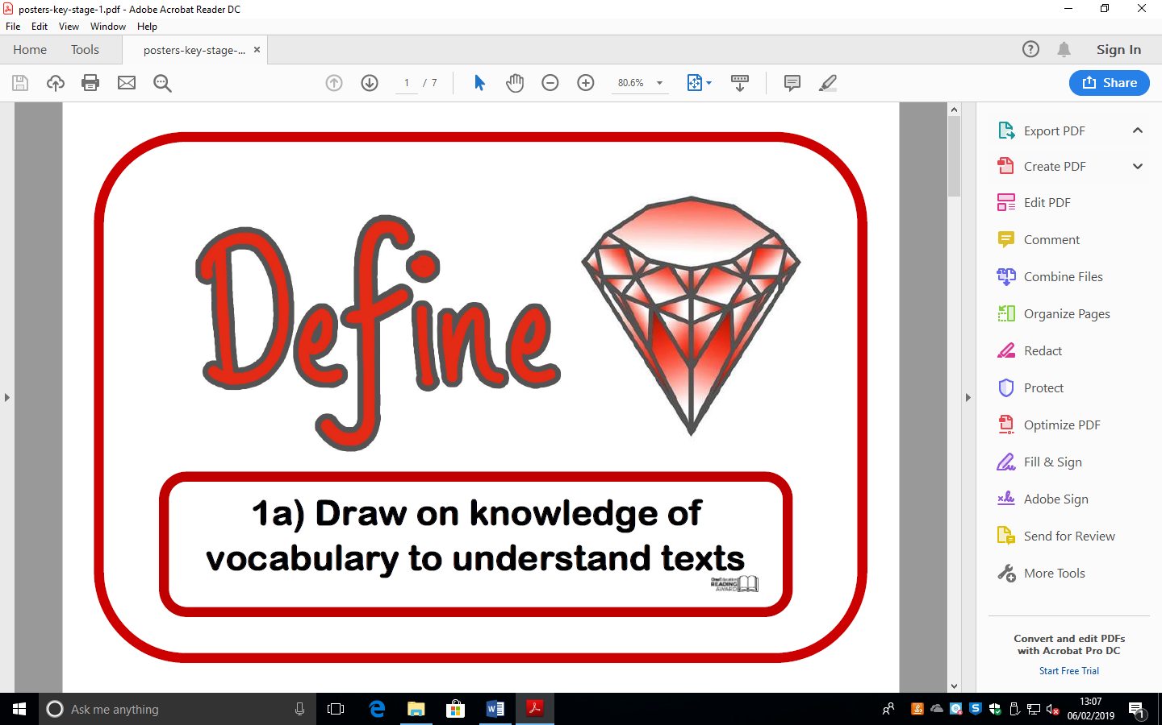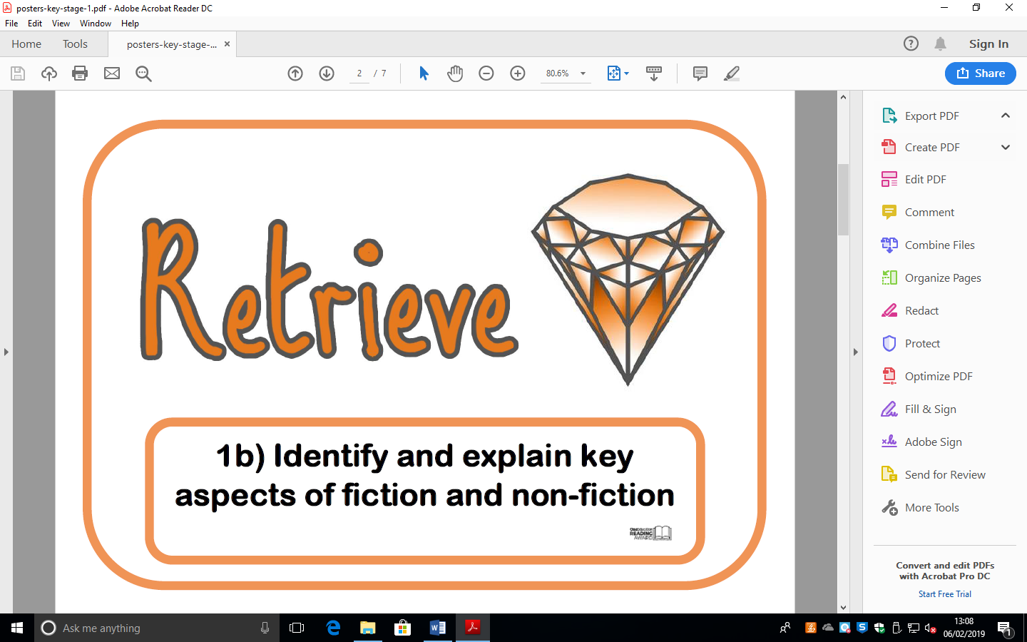
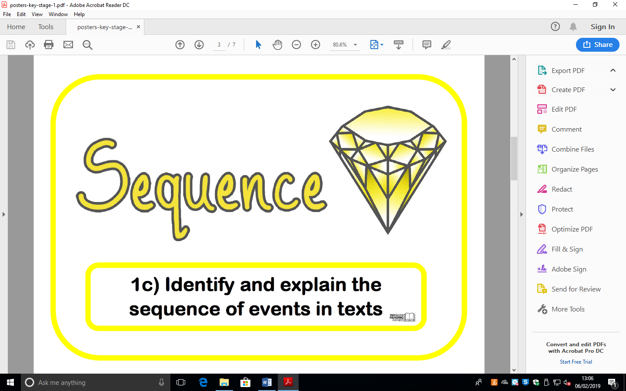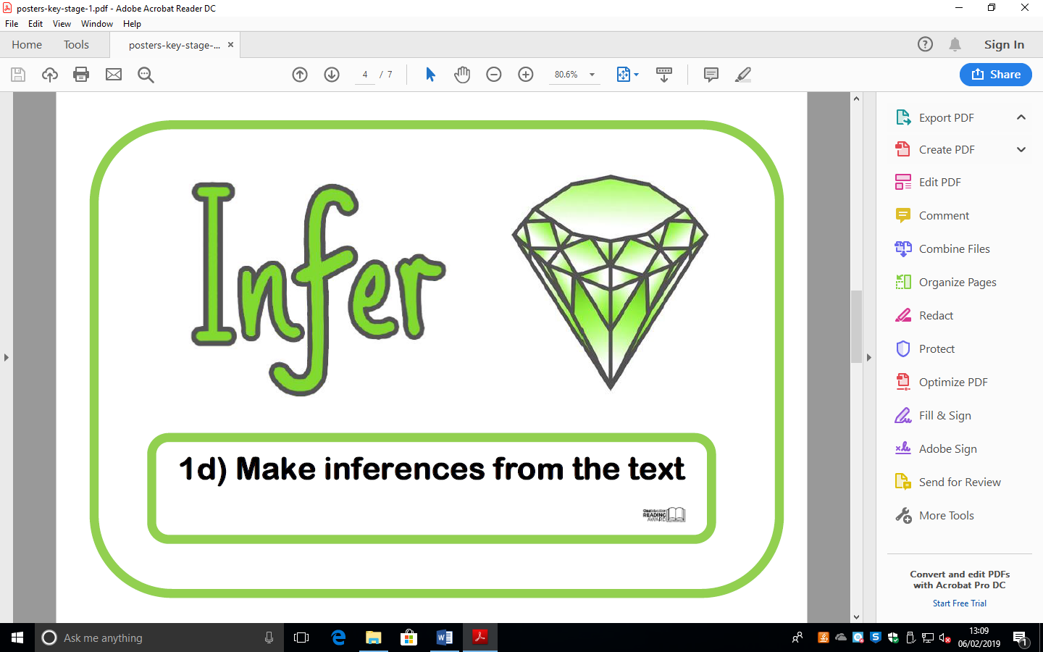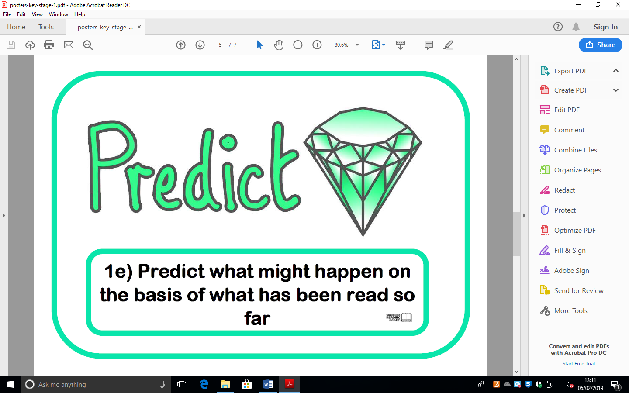

Key Stage 2 Reading Gems:
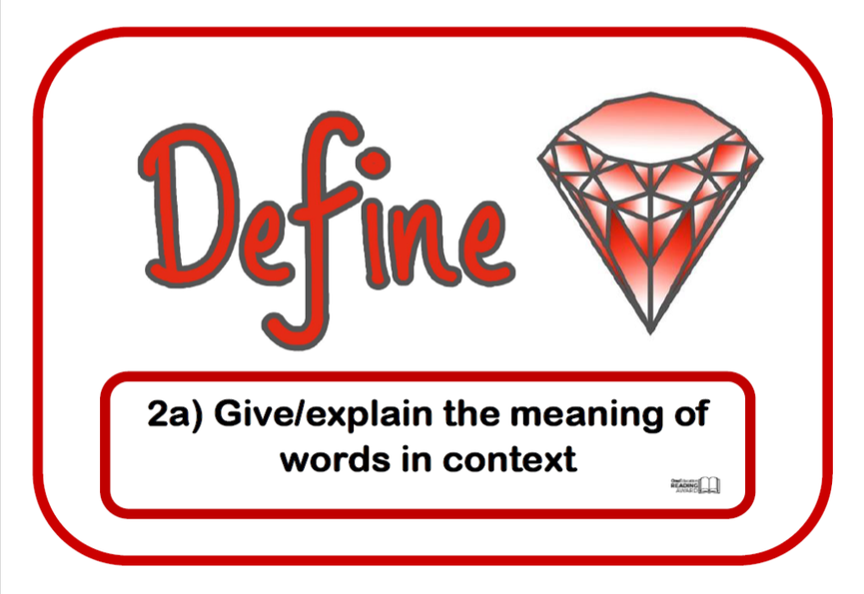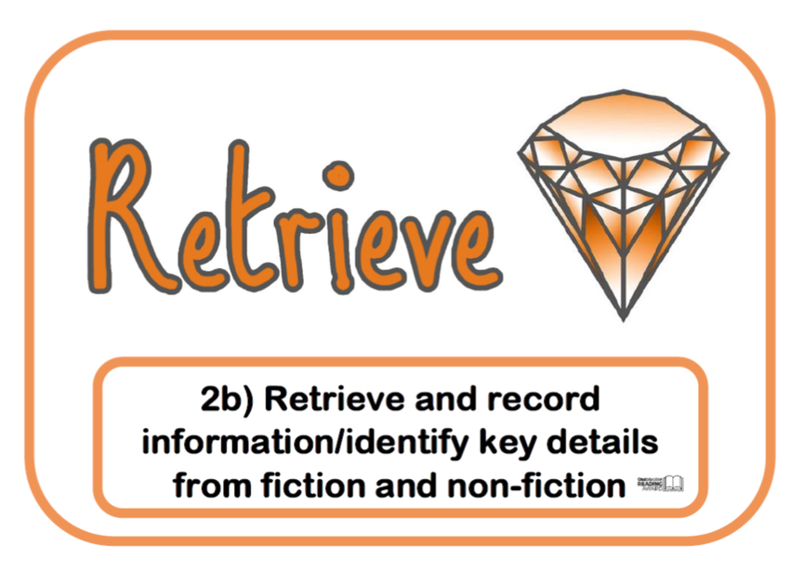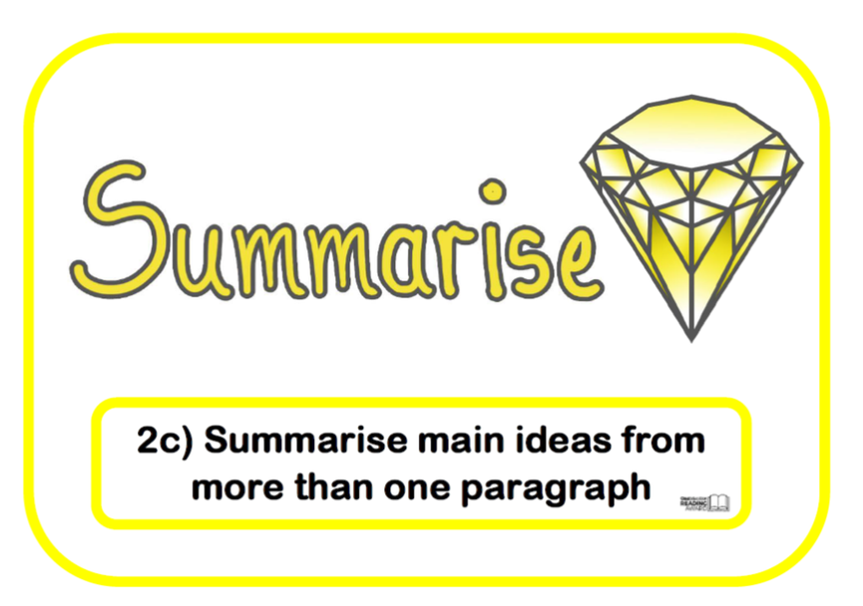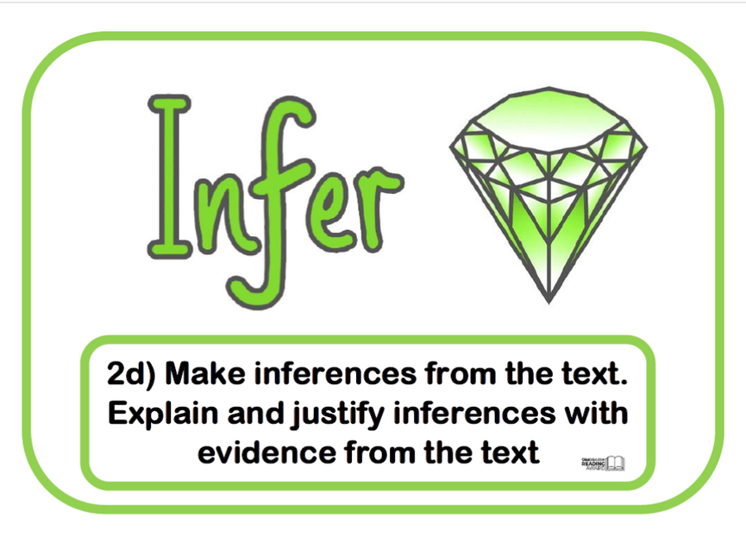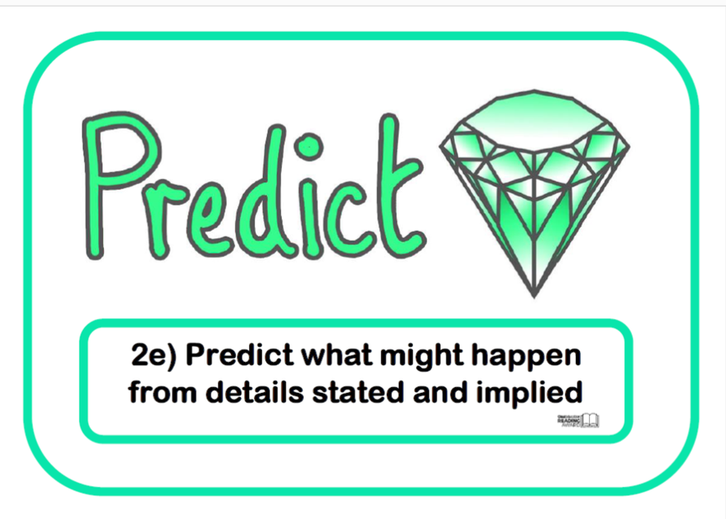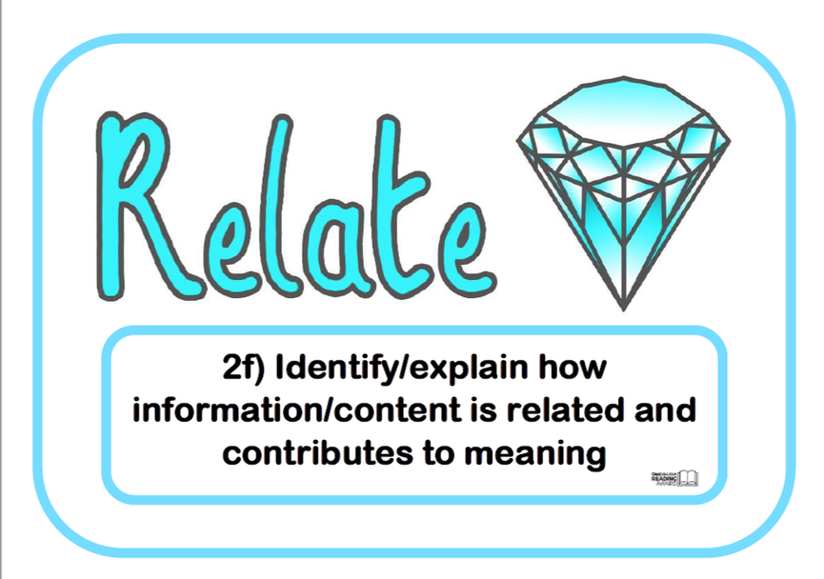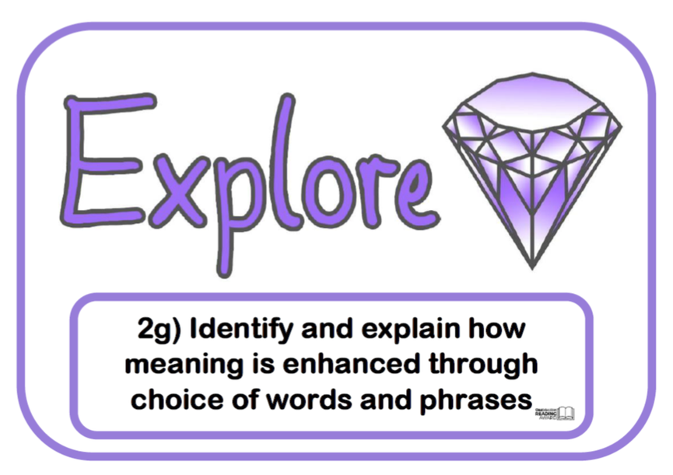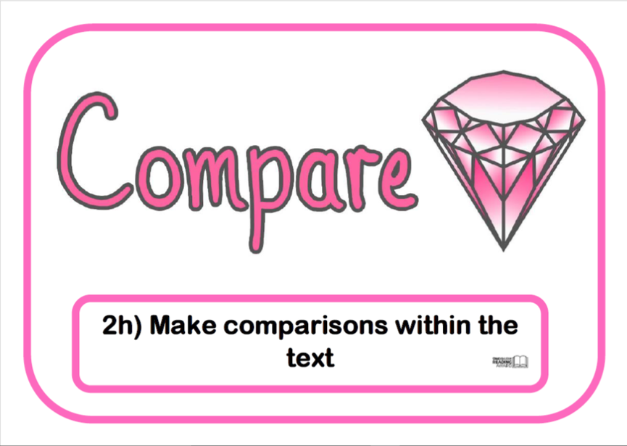

Cross curriculum Reading opportunities
Reading is not restricted to the English lesson. Many opportunities are provided for children to practise and extend their reading in other subjects. Reading for pleasure and enjoyment is given a high priority and time is set aside for this.

Shared Reading
Shared reading takes place within the English lesson; the teacher models the reading process to the whole class as an expert reader. Teaching objectives are pre-planned and sessions are characterised by explicit teaching of specific reading strategies, oral responses from children and collaboration. The children join in, where appropriate, with the reading of the text. The texts selected are quality texts that reflect the learning objectives.

Listening to Reading
Children frequently have the opportunity to listen to their teachers reading a whole-class story. These sessions allow the children to all enjoy a story that may be too difficult for them to read independently. EYFS and KS1 have daily story sessions whereby they listen to their teacher reading a short storybook of their choice. KS2 have regular ‘Drop everything and listen’ (DEAL) sessions, where the class listen to a section of novel (written by their class author) being read by an adult.

Individual Reading
Children have access to graded reading scheme books to support the development of their individual reading skills. Children start the reading scheme in Foundation Stage and continue this through to Year 6 until they become competent, independent readers.

In all key stages children take home reading scheme books. A home/school reading diary is used to record books read. Children are encouraged to read daily at home to an adult. The adult then signs the reading diary and adds a comment.

Whenever possible, 1-1 extra reading is provided by staff, especially to boost basic reading skills for children who are working below age related expectations.

Guided Reading
In KS1, children work in small groups guided by an adult. The lesson is structured around an age/ability-appropriate book which the teacher facilitates understanding and helps the children to explore the text/illustrations in more detail. A variety of fiction and non-fiction books are used for these sessions.
Children in KS2 that require further support with understanding and exploring age-related texts will be involved in weekly Guided Reading intervention sessions.

Phonics Lessons
At Pinders Primary School we believe that all our children can become fluent readers and writers. This is why we teach reading through Little Wandle Letters and Sounds Revised, which is a systematic and synthetic phonics programme. We start teaching phonics in Nursery/Reception and follow the Little Wandle Letters and Sounds Revised progression, which ensures children build on their growing knowledge of the alphabetic code, mastering phonics to read and spell as they move through school. As a result, all our children are able to tackle any unfamiliar words as they read. At Pinders Primary School we also model the application of the alphabetic code through phonics in shared reading and writing, both inside and outside of the phonics lesson and across the curriculum. We have a strong focus on language development for our children because we know that speaking and listening are crucial skills for reading and writing in all subjects.
*See Phonics Policy*

Read and Respond
Throughout school from Foundation Stage to Year 6, children take part in a specific reading comprehension lesson every week. This lesson is based upon a text which has been chosen primarily because of the level of challenge it presents, either challenge through language, theme or issues. A unit of work is planned around a text and each child reads a chapter/section of the story every week at home in preparation for this lesson. This is a crucial part of homework because it allows the time in lesson to be spent exploring a wider range of comprehension skills in depth rather than simply reading the chapter and retrieving basic information as a recap.
Skills are focused around our reading gems, such as summarising and predicting using evidence from the text, evaluating and analysing an author’s craft, making judgements about characters’ motivations and debating and examining key issues are just a selection of the vital comprehension experiences our children participate in weekly.
The work produced in these lessons is recorded in a Read and Respond Journal which showcases the variety of developing reading thinking skills on offer.

Here are some examples of the texts we use in our Read and Respond sessions:
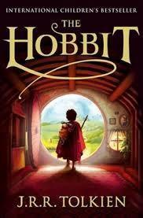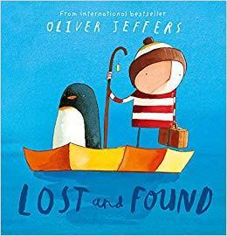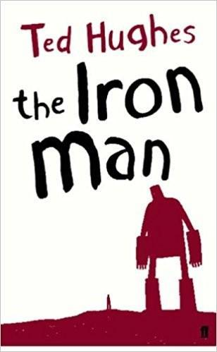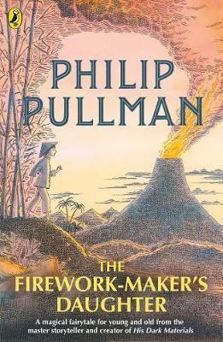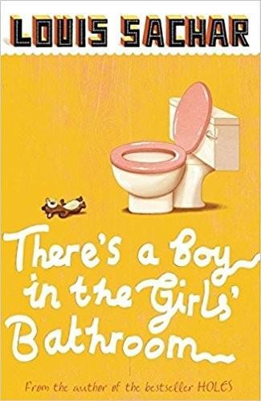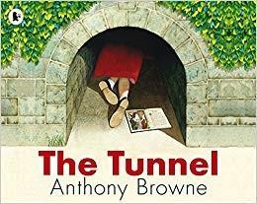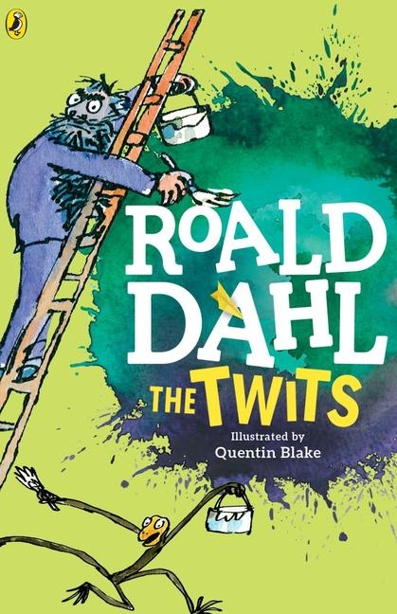

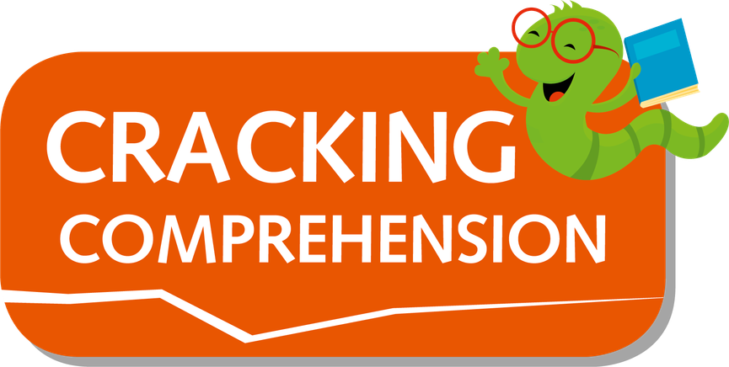
Cracking Comprehension

Alongside the broad depth of comprehension skills explored and developed as part of the Read and Respond lessons, our children take part in a weekly session of specific test related comprehension skills using some texts from the ‘Rising Stars Cracking Comprehension’ scheme and some age-related text linked to topics being taught during the term. These age appropriate texts and questions ensure that our children develop the skills to apply their reading understanding in very focused and test based scenarios.
Weekly lessons allow for children to practise and experience different exam style questions as well as observe reading skills being modelled. Cracking comprehension lesson are also focused around our reading gems, and focus on reading skills such as summarising and predicting using evidence from the text, evaluating, analysing and making judgements about characters’ motivations.

Our Reading schemes
Pupils read through a set of book banded books which are enhanced each year in order to provide a wider breadth of reading materials for pupils. Each colour in the book band represents a different reading stage. We assign children to a book band based on their word reading skills and their ability to understand and explain what they are reading. Earlier book bands, up to gold, are linked to phonics phases. The book bands are named by colour and follow the pattern below (going left to right along each row):

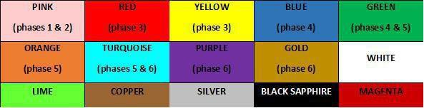

Children will be assigned to a book band when they enter the school and will then progress through the stages at their own pace until they leave us. It is important to note that the book bands are designed to be different lengths, so while some book bands may be completed over a half term, most are designed to last a few months and some up to a year or more, particularly in the higher bands.

Assessment
- During Guided Reading, progress with reading skills are recorded on guided reading sheets that also have Content Domain objectives on linked to the National Curriculum.
- In KS2 children’s reading speeds are monitored termly using PiXl reading speed texts.
- Reading assessments are carried out three times a year.
- End of years SATs test in Year 2 and Year 6.

At a Glance - The Non-negotiables Teaching of Reading

Range of reading per week
- The equivalent of 1 hour of Read and respond – this may be a 1 hour session or broken into smaller sessions throughout the week in KS1.
- The equivalent of 1 hour of cracking comprehension – this may be a 1 hour session or broken into smaller sessions throughout the week in KS1.
- High priority readers must be listened to 3 or more times a week by an adult.
- All pupils will be listened to read 1-1 by the class teacher once every three weeks.

Planning
- All reading planning & I cans to be linked to the reading gems.
- National Curriculum age-related expectations to be taught.
- Read and Respond plans and Cracking Comprehension plans are saved and shared to ensure consistency of teaching.
- Guided Reading plans to identify a clear I can and the specific reading Gem to be focussed on that session.
- Books are to be used as a stimulus within other subject areas.
- All subject blocks, except PE, computing and music, must have a comprehension lesson taught within the block.
- All lessons in all subjects are to be linked by reading gems where appropriate.

Assessment Records
- Teacher reading journals (Green File).
- Individual reading by any staff member to be recorded in the pupils reading records.
- Guided Reading outcomes to be recorded on the Guided Reading Planning Sheet using the RAG. rating system.
- Formative reading assessments are carried out three times a year, Year 2-6 PiXL assessment material.
- Formative assessments are analysed by PiXL and the outcomes used for precision teaching.
- End of years SATs test in Year 2 and Year 6 are carried out.
Book Corners
- Books are cared for and organised.
- The space is accessible for children and comfortable for them to use.
- The display materials are well maintained, inviting and age appropriate.
- A range of different genres of age appropriate text are available.
- Reading Gems to be prominently displayed.

Library
- Children have opportunities to visit the school Library on a weekly basis.
- Children are encouraged to read for pleasure at home and at school.
- Books chosen from the Library should demonstrate children’s desire to challenge
themselves and teachers must encourage and monitor this.
- Children are encouraged to use the outdoor community library with parents after school.

Subject Knowledge

- Teachers are expected to keep their subject knowledge of children’s literature and authors up to date, through websites, twitter and personal reading.

