Book List – Science
KS1
Cycle A

Explorers
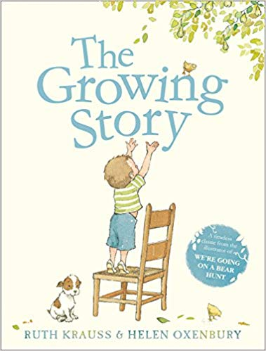 The Growing Story – Ruth Krauss & Helen Oxenbury
Why this book was chosen:
The topic is Explorers, pupils will be learning about Humans in Science.

Paddington’s Travels
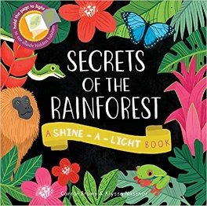 Secrets of the Rainforest – Carron Brown & Alyssa Nassner
Why this book was chosen:
The topic is Paddington’s Travels, pupils will be learning about Animals and their Habitats (including the Rainforest) in Science.

London’s Burning
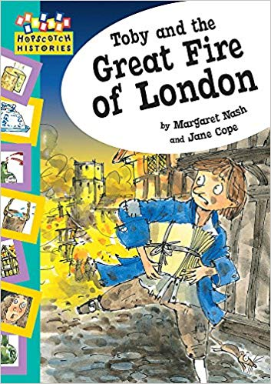

Toby and the Great Fire of London - Margaret Nash and Jane Cope

Why this book was chosen:
The topic is London’s Burning, pupils will be learning about Materials in Science.

Book List – Science
KS1
Cycle B

Traditional Tales
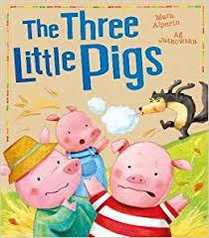

The Three Little Pigs – Mara Alperin

Why this book was chosen:
The topic is Traditional Tales, pupils will be learning about Materials in Science.

Wonderful World
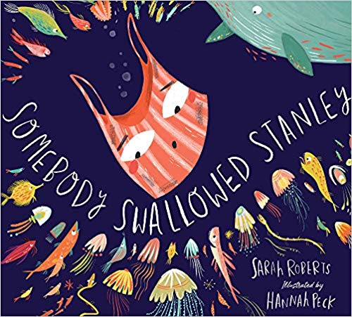 Somebody Swallowed Stanley – Sarah Roberts & Hannah Peck
Why this book was chosen:
The topic is Wonderful World, pupils will be learning about Animals and their groups in Science.

How does your Garden Grow?
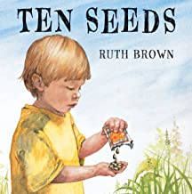 Ten Seeds – Ruth Brown
Why this book was chosen:
The topic is How does your Garden Grow? , pupils will be learning about Plants in Science.
Book List – Science
LKS2
Cycle A

Stone Age to Iron Age - Rocks
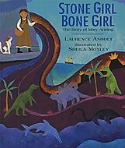
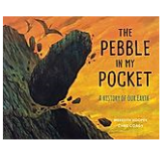

The pebble in my pocket - Meredith Hooper & Chris Coady
Stone Girl Bone Girl - Laurence Anholt and Sheila Moxley

Why this book was chosen:
The topic is Stone Age to Iron Age , pupils will be learning about Rocks in Science.

Stone Age to Iron Age – Animals
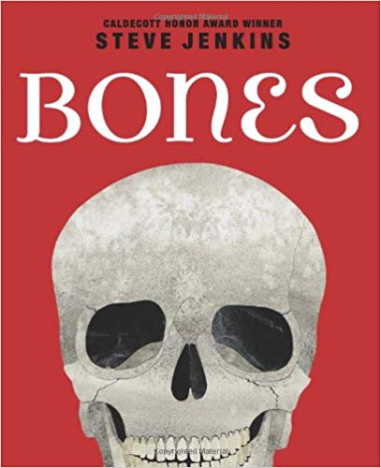

Bones – Steve Jenkins

Why this book was chosen:
The topic is Stone Age to Iron Age , pupils will be learning about Animals in Science.
.Greeks
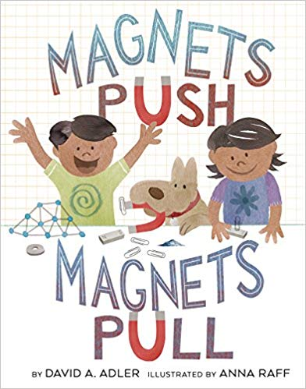
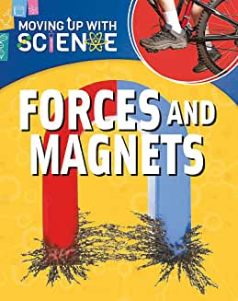
Forces and Magnets (Moving up with Science) – Peter Riley

Magnets Push, Magnets Pull - David A Adler
and Anna Raf
Why this book was chosen:
The topic is Greeks , pupils will be learning about Forces & Magnets in Science.

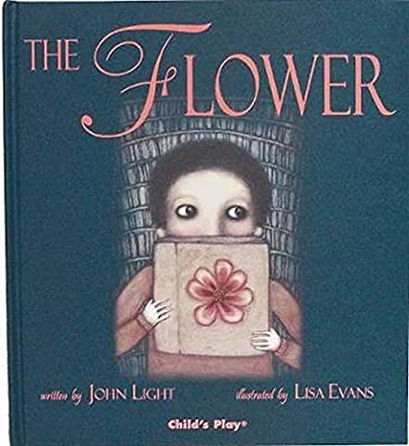
Local Area – Animals

The Flower - John Light

Why this book was chosen:
The topic is The Local Area, pupils will be learning about Plants in Science.

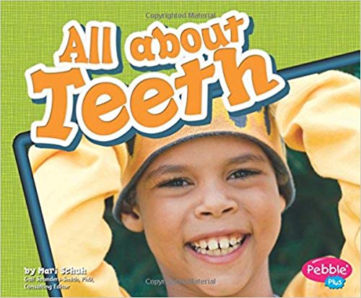
Local Area – Digestive System, Teeth , Food
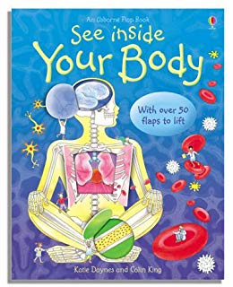

All About Teeth – Mari C. Shuh
See Inside Your Body – Katie Daynes

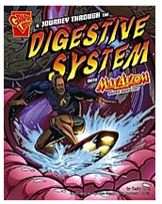
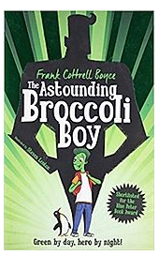

A Journey Through the Digestive System –Emily Sohn
The astounding broccoli Boy – Frank Cottrell Boyce

Why this book was chosen:
The topic is The Local Area , pupils will be learning about Humans in Science.

Book List – Science
LKS2
Cycle B

Romans – States of Matter
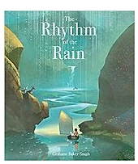 The Rhythm of the Rain - Grahame Baker-Smith
Why this book was chosen:
The topic is Romans , pupils will be learning about States of Matter in Science.

Window on the World – Animals
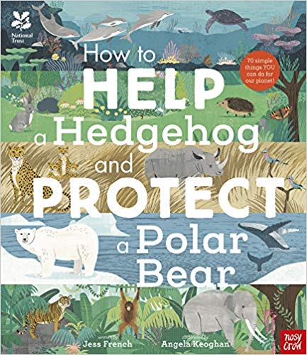

How to Help a Hedgehog and protect a polar bear - Jess French and Angela Keoghan

Why this book was chosen:
The topic is Window on the World , pupils will be learning about Animals in Science.

Anglo- Saxons

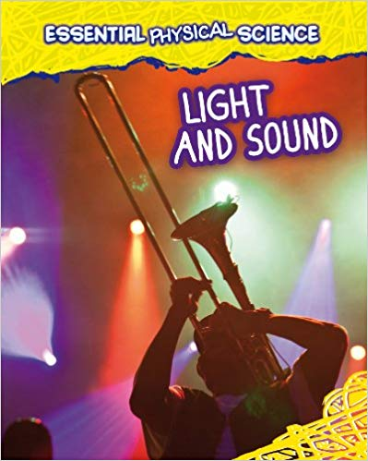 Light & Sound – Louise Spilsbury and Richard Spilsbury
Why this book was chosen:
The topic is Anglo Saxons? , pupils will be learning about Sound & Light in Science.

Book List – Science
UKS2
Cycle A
Poppies Peace and Power – Electricity
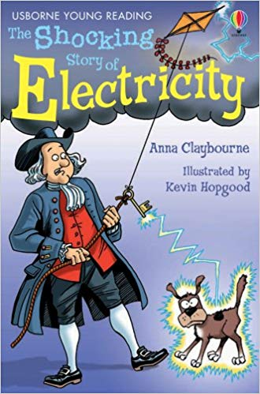

The shocking story of electricity - Anna Claybourne
Why this book was chosen:
The topic is Poppies, Peace & Power, pupils will be learning about Electricity in Science.
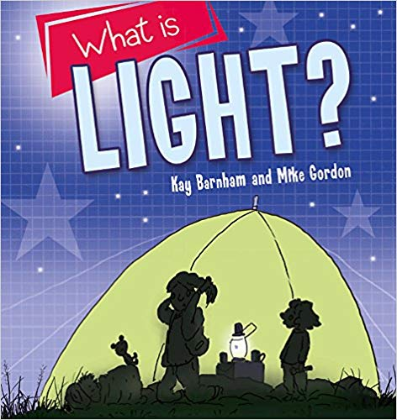
Poppies Peace and Power – Light

What is Light? - Kay Barnham and Mike Gordon

Why this book was chosen:
The topic is Poppies, Peace & Power, pupils will be learning about Light in Science.

.Natural Disasters – Materials
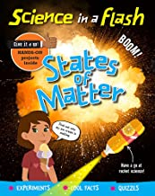States of Matter – George Amsom-Bradshaw
Why this book was chosen:
The topic is Natural Disasters, pupils will be learning about Materials in Science.
Space
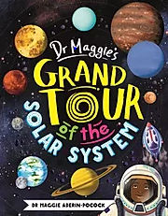
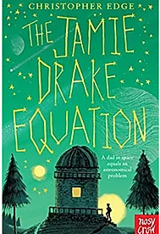

The Jamie Drake Equation – Christopher Edge
Dr Maggie’s Grand Tour of the Solar System – Dr Maggie Alderin - Pocock

Why this book was chosen:
The topic is Space, pupils will be learning about Earth & Space in Science.

Book List – Science
UKS2
Cycle B

Vikings – Humans and Animals

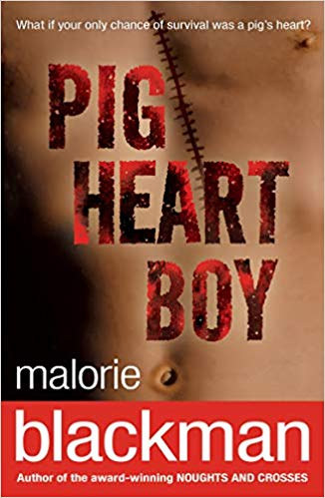
Pig Heart Boy – Malorie Blackman
Why this book was chosen:
The topic is Vikings , pupils will be learning about Humans in Science.

Egyptians – Micro Organisms
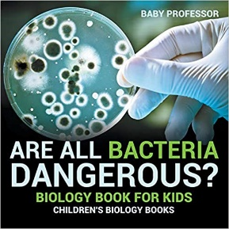Are all bacteria dangerous Baby Professor
Why this book was chosen:
The topic is Egyptians , pupils will be learning about Micro-Organisms in Science.

Rainforest
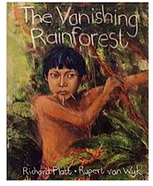

The Vanishing Rainforest - Richard Platt & Rupert van Wyk
Why this book was chosen:
The topic is The Rainforest , pupils will be learning about Evolution in Science.

Book List – Science
UKS2
Cycle B

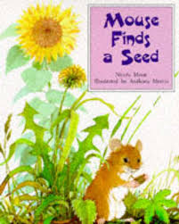

Mouse Finds a Seed – Nicola Moon and Anthony Morris

The topic is How does your Garden Grow? , pupils will be learning about Plants in Science.

