Adult Visitors and Volunteers Policy



Pinders Primary School

Pinders Primary School Visitors and Volunteers Policy Oct 2024

Adult Visitors and Volunteer Policy

Introduction
Volunteers at Pinders Primary School bring with them a range of skills and experience that can enhance the learning opportunities of the children at our school. School benefits from developing well planned, active parental and community links. Participation by adults in the activities of the school on a voluntary basis helps to achieve this.

Aim
The aim of this policy is to establish expectations for both staff and volunteers/visitors regarding the work undertaken by volunteers and their conduct whilst in school.

Volunteer in our school fall into three main groups:
- One-off volunteer helpers, including parents accompanying class trips or volunteering at school events
- Volunteers who come in regularly to hear children read, support other curriculum areas or deliver after-school clubs.
- Trainee teachers and students on work placement.

Our volunteers include (this list is not exhaustive):
- Members of the Governing Body
- Parents, carers, guardians, elder siblings or Grandparents of Pupils
- Students on work experience/placements
- Ex-members of staff
- Staff family members
- Members of the school PTFA
- Sports coaches
- Volunteers from business and organisations.

Becoming a Volunteer -Procedure
Anyone wishing to become a volunteer may either approach a member of the SLT who will request that they complete a volunteer application form (see Appendix 1).
If a suitable volunteering opportunity can be identified, then the following process will be carried out:

- The person will be invited to attend the school for an informal discussion with a member of SLT to ensure they are suitable for the role. The school reserves the right to refuse an approach at any time and not give a reason for this.
- If suitable the volunteer will be asked to complete a Volunteers agreement (see Appendix 2)
- One characters reference will be sought from the referee provided on the registration form. It is the volunteer’s responsibility to contact their referees to ensure that references are received by the school in a timely manner.
- A Risk Assessment for Volunteers (see Appendix 3) will be carried out to determine whether an Enhanced DBS check needs to be carried out, and whether this will also include a Barred list check. Generally, most volunteers will be asked to undergo an Enhanced DBS check, unless they are classified as low risk. A Barred List check will be requested for any volunteer who is in regulated activity.
- The volunteer will be given appropriate school policies, procedures, health and safety information and safeguarding information to read. They must sign to say they have read and understood this information.
- The volunteer will be linked to a designated teacher, whose responsibility it is to make them aware of the role and responsibilities they will be undertaking.
- Volunteer records will be kept in the school office so we keep track of who is working in our school, where they are placed and for how long they will be with us.
Before starting to volunteer in a school, the above steps must be completed. No volunteer may start regular volunteering without the appropriate checks, unless with the written permission of the Head Teacher.

This is not required where a volunteer is engaged in a one-off activity, for example a parent helping on a school trip, or coming into class for a specific activity. However, these volunteers must be supervised at all times, and never left alone with a child.

Aims and Values
All adults who work in our school, whether a paid member of staff or volunteer, are expected to work and behave in such a way as to actively support and promote our school aims and values which are as follows:


We aim to:
- We will provide a curriculum that is broad and balanced, that will help children prepare for the opportunities and responsibilities that are needed for now and later in life.
- We will encourage the children to develop spiritually, morally, culturally, mentally and physically.
- We support a policy of inclusion, where there are equal opportunities for all.
- We aim to provide a happy and healthy school environment where children and adults respect each other and take responsibility for their own actions.
- We aim to safeguard and promote the welfare of all children in our care by providing an environment in which they are safe and secure and can be supported in their physical and emotional needs.
- We expect everyone to achieve high standards of work and behaviour both inside and outside school.
- We strongly believe that communication is crucial between all staff, parents and children and we will foster an ethos of openness whilst maintaining appropriate confidentiality.

2Supervision
All visitors and volunteers are under the supervision of SLT and the class teacher of the class to which they are assigned. Teachers retain responsibility for the children at all times. Visitors and volunteers should have clear guidance from the teacher as to how an activity involving children may be carried out and what the expected outcomes of any activity are. Visitors and volunteers are encouraged to speak to the teacher if they have a query about any aspect of a child’s
understanding or behaviour.

Safeguarding Children
The welfare of our children is paramount. To ensure the safety of our children we adopt the following procedures:

- All visitors and volunteers are given a copy of this policy.
- Visitors and volunteers must wear an identification badge whilst on the premises
- All volunteers must sign a Visitors and Volunteers Agreement (Appendix 2)
- If you are supporting on a school trip you will be asked to read and sign (Appendix 5)
- The school reserves the right to ask for a character reference if necessary
- We encourage all visitors and volunteers who work with children to have a Disclosure Barring Service ( DBS)
- Anyone visiting or volunteering on a regular basis and who has substantial access to children must have a full, up to date DBS check.
- Under NO circumstances must you work alone with a child without DBS

How to respond to a disclosure
- Use open non-leading questions
- Record exact wording
- Report to Head Teacher/ Deputy Head Teacher of other designated safeguarding lead.
- It is imperative that everything remains confidential.

Disclosure and Barring Service
DBS for the children’s safety all regular visitors to school are required to undergo a police clearance check for volunteers – DBS. This is only for volunteers who are involved in regulated services – i.e. attend school on a volunteer basis for more than three times in one month. The Headteacher has the final say on volunteers who help in school. Irregular volunteers are permitted onto the premises, may help out on school visits but on the basis that they are never alone with a child or a group of children.

An entry will be made on the school’s Safeguarding Single Central Record and a file maintained with the confidential details of the volunteer which will be retained by school for 7 years after the volunteer resigns from their volunteering responsibilities.

The exceptions to this are:
- Work Experience Students or University Placements who apply via their educational establishment as it is expected that all necessary safeguarding checks have been carried out by the educational establishment before arriving at Pinders Primary School. The student will be expected to share their DBS certificate with the business manager and will not be placed in a class with any family connection.
- One-off volunteers i.e. assisting with a school walk, Primary Futures, a fund-raising event or a school visit will not require a DBS. Care should be taken to ensure these volunteers do not have sole responsibility for a group of children or provide any form of intimate care.

Deployment of Volunteers
Volunteers are usually placed in a class other than the one that their own child, sibling or family member may be in. Volunteers will be asked to support in classes where there is most need.

Confidentiality
Volunteers in school are bound by a code of confidentiality. Any concerns that visitors and volunteers may have about the children they come into contact with should only be discussed with the class teacher. Visitors and volunteers concerned about what another adult in the schools says or does, should raise the matter directly with the head or deputy head teacher.

Health & Safety
The school has a Health and Safety Policy available on request from our school office. Class teachers ensure that visitors and volunteers are made aware of any emergency procedures (eg. what to do in the case of a fire alarm) and about any safety issues associated with a particular task (eg. during a practical task). Visitors and volunteers are asked to exercise due care and attention and report any obvious hazards or concerns to the class teacher. Visitors and volunteers must not deal with any situation regarding a child's personal hygiene, administer medicine or give first aid.

Signing In:
All volunteers must sign in at Reception area before entering school and this must be done on each separate visit day. They will be issued with a Visitor Badge which must be worn around school. When leaving school, they must sign out and return the badge. During their time in school volunteers must adhere to the Health & Safety Policy.

Complaints Procedure
Any complaints about a visitor or volunteer will be referred to the head or deputy head teacher. Any complaints made by a visitor or volunteer will also be referred to the head or deputy head teacher.

The head reserves the right to take the following actions:
- To speak with the individual about a breach of our agreement and seek reassurance this will not happen again
- Offer an alternative placement in another class
- Inform the visitor or volunteer that the school no longer supports their attendance at school.

Monitoring and Review
- The day to day monitoring of volunteers and this policy is the responsibility of the Headteacher and will be reviewed at least every two years. The Headteacher does emphasise to the Governing Body, the importance of this help from volunteer adults.

Linked Policies:
- Safeguarding and child protection
- School Visits.

Review September 2026

Appendix 1

Pinders Primary School
Head teacher: Mrs L. Kemplay

Volunteer Application Form - For New Volunteer

Name of Volunteer: First name……………………………………………………….
Surname…………………………………………………………..
Date of Birth……………………………………………………….
Address……………………………………………………………………………………………………………………………………….
……………………………………………………………………………………………………………………………………………………..
Phone: Home………………………………………………………………Mobile…………………………………………………………..
Email Address :……………………………………………………………………………………………………………………………….

What activities/ areas of the schools work would you like to help with?

Are there any particular age groups/ classes you would like to work with?

Do you have any disabilities/ other needs we need to take into account or adjustments we need to make to allow you to work as a volunteer in school? (please give details).

Appendix 2

Pinders Primary School Visitors and Volunteer Agreement

Thank you for visiting or offering your services as a volunteer at Pinders Primary School. Your help is greatly appreciated and we hope that you will gain much from your experience here.

Please read and sign this agreement and hand it in to the school office. You will receive a copy of it for your records.

- I have received and read the Visitors and Volunteer Policy
- I agree to support the school’s Aims and Values
- I agree to treat information I learn from being in the school as confidential

DBS Check – circle as appropriate
Yes | No | Applied for

If you already have a DBS certificate, please hand it to the school office and a copy will be made for the school records.

Confidentiality Agreement
Whilst in school, it is possible that you may come in to contact with confidential/sensitive information. This may be concerning people with whom you have dealings outside of the school setting such as; parents, children, staff and other individuals representing the school. Please remember that any information that you are privy to whilst at this school is confidential and must remain so. This includes personal and social media interactions.

If you have concerns regarding a breach of sensitive information or indeed, feel there is a matter which needs to be brought to the attention of the Headteacher, please contact the school office as soon as possible.

Below is a form acknowledging your agreement of the above statement. Please ensure that this form is returned as soon as possible. The school views any breach of confidentiality as a very serious matter and will take appropriate action in the event of any such breach.

I have read, acknowledged and agree to abide by the above confidentiality statement.

Signed………………………………………………………………..…………………………………

Name…………………………………………………………………………………………………..

Date……………………………………………………………………………….…………………..

Appendix 3
Risk Assessment Template for Volunteers working in Schools who are NOT in Regulated Activity

Name of Volunteer |  | Start Date
Person conducting the risk assessment

Person conducting the risk assessment

Is the Volunteer going to be working in Regulated Activity? [Tick one box]
A Yes ☐ (if “Yes” you must obtain an Enhanced DBS certificate with Barred List check and you do not need to fill out this risk assessment further)
B No ☐ (if “No” you may choose to obtain an Enhanced DBS certificate without a Barred List check, based on this risk assessment and your professional judgement)

Factors to Consider | Description |  |  |  | Risk score
Will they have direct contact with children?
Frequency of working directly with children?
Age range of the children? |  |  |  |  | n/a
Any contact with children particularly vulnerable?
Assisting with any personal care? | (If “yes” the Volunteer is Regulated Activity, tick box A above)  .
What tasks will they be doing?
Frequency of working in the school?
Will they be working with children outside of school hours? when? | (Work between 2am and 6am is Regulated Activity, tick box A above)
Will they be working with children off school premises? Where? When?
Is the school a residential setting?
What is the association of the Volunteer with the school?
How well does the school know the history of the Volunteer?
What do you believe is their reason for volunteering?
Can the volunteer provide a relevant reference from someone they have worked or volunteered for?
Can the volunteer provide a reference from someone who knows their work with children?
Does the volunteer have a history of paid or voluntary work with children?
Does the Volunteer have a recent DBS certificate from another role?
Is the Volunteer currently signed up to the DBS update service?
Are there any known or suspected concerns around working children?
Any other factors to be taken into account.
Total Risk Rating [total up the risk scores for each factor]
Overall Risk level [tick one box – refer to guide below] |  | Low ☐ | Medium ☐ | High ☐
Agreed Action: [tick box]
Enhanced DBS Check NOT required ☐ Enhanced DBS Check IS needed ☐
Comment on reason:

Sign Off:
Name of person signing off risk assessment:
Role:
Signature: ………………………………… Date:

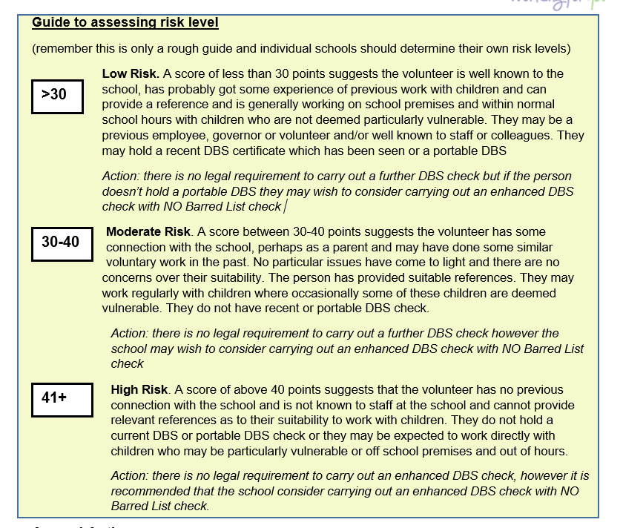
Appendix 4
Off-Sites Visits – Volunteer Agreement

Thank you for volunteering. School trips are an integral part of learning at our school and afford many children opportunities which are outside their usual experiences. We are pleased that you have come forward as a volunteer helper: you will have an important role to play in the success and safety of this school trip.
The class teacher has overall responsibility for the children at all times, but designates responsibility to voluntary helpers who may have charge of a small group.

Please read and return this agreement to the office. This forms part of our school’s risk assessment planning.

The Role of a Volunteer Helper
- To be responsible for and look after, in equal measure, all of the children in your group
- To stay with your allocated group and ensure their well-being and safety for the duration of the trip
- To promote polite, respectful and courteous behaviour amongst the group and towards members of the public
- To ensure that your group keeps up with the rest of the school visit party
- To contact your class teacher if there are issues with first aid, safety or behaviour
- To show a commitment to the group, an interest in the focus of the visit and assist children in their learning by helping them to read signs/labels/information, asking questions that encourage children to think about the task and by helping to explain areas of interest.
- To follow guidance from school staff

What is not permitted
- Volunteer are not allowed to bring additional siblings on the school trip
- Volunteer are not allowed to re-organise school visit groups.
- Please do not use your mobile phone unless the call or text is urgent
- Volunteers are not allowed to smoke, drink alcohol or engage in any illegal practices
- Volunteers are not allowed to take photographs of the children unless requested to do so by the teacher in charge on a school owned device.
- Volunteer helpers are not allowed to give/buy their group treats e.g., ice-creams, biscuits, sweets – before, during or after the school trip.
- Volunteers are not allowed to touch or reprimand children but should speak to a school staff member if there are any difficulties.

First Aid
For each class on the school visit, there will be at least one qualified first aider. You will be informed if any child in your group has medication/needs. If medicine needs to be administered, this will be done by a member of staff. Under no circumstances will a volunteer be asked to administer medication of any kind. All other medicines and first aid box(es) will be carried by staff.

Emergencies
Please inform a member of school staff as soon as possible. If you are separated from the rest of the school party, please telephone one of the staff members or the school.

I have read the Volunteer Policy
I understand and agree to the terms and conditions as stated in the policy
I will support the young people in enjoying the trip and actively contribute to the smooth running of the occasion.

Signed……………………………………………… Name………………………………………………..

Date………………………………………………….

Refer to Annex F in Keeping Children Safe in Education for the Statutory Definition of Regulated Activity

