**Book List – Book List – Design & Technology**

**LKS2**

**Cycle A**

**(Stone Age to Iron Age – Rocks) - Christmas Tree Decorations**

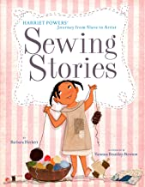

[**Sewing Stories: Harriet Powers' Journey from Slave to Artist**](https://www.amazon.co.uk/Sewing-Stories-Harriet-Powers-Journey-ebook/dp/B00SEF633Q/ref=sr_1_1?keywords=from+slave+to+sewing&qid=1575471393&s=books&sr=1-1-catcorr)

**by**[**Barbara Herkert**](https://www.amazon.co.uk/Barbara-Herkert/e/B00LV9S61Y?ref=sr_ntt_srch_lnk_1&qid=1575471393&sr=1-1-catcorr)**and Vanessa Brantley-Newton**

**Greeks – Greek Cooking**

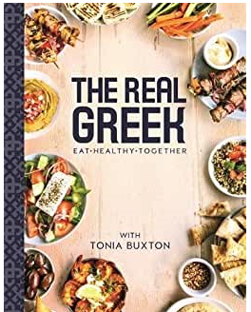

**The Real Greek – Tonia Buxton**

**Local Area - Mine Cart**

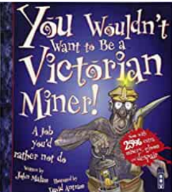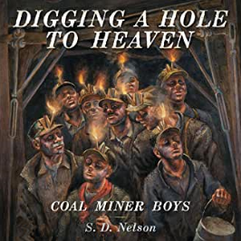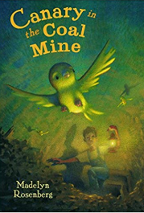

**Canary in the coal Mine – Madelyn Rosenberg**

**Digging a hole to heaven – S D Nelson**

**You wouldn’t want to be a Victorian miner! – John Malam & David Antram**

**Book List – Book List – Design & Technology**

**LKS2**

**Cycle B**

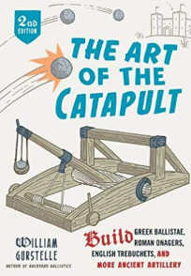**Romans – Catapults**

**The Art of a catapult - William Gurstelle**

**Window on the World – Bridges**

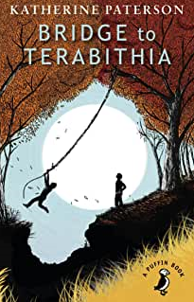

**The Bridge to Terabithia – Katherine Paterson**

**Anglo- Saxons - Cooking**

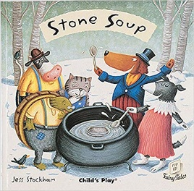

**Stone Soup – Child’s Play**