Book List – Design & Technology
KS1
Cycle A

(Explorers) – Christmas Decorations
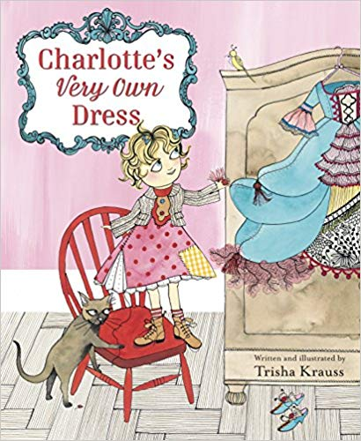
Charlotte’s Very Own Dress - Trisha Krauss

London’s Burning – Fire Engine
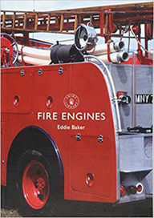
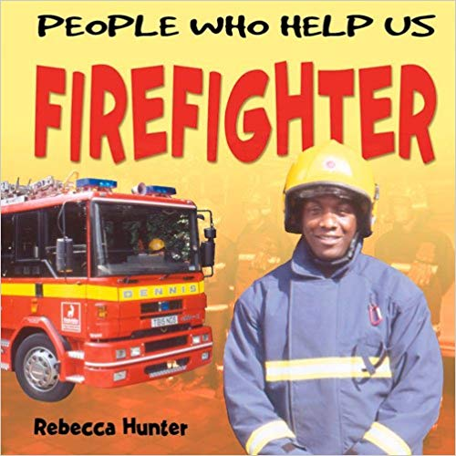

People who help us Firefighter - Rebecca Hunter
Fire engines - Eddie Baker

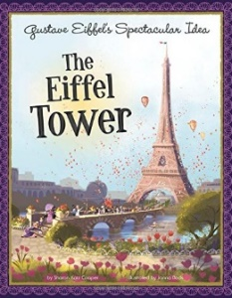
Paddingtons Travels - Towers
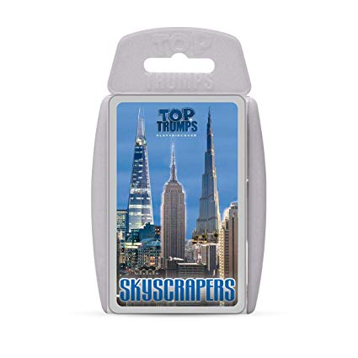

ORT - Paris Adventure
Gustav Eiffels spectacular intro The Eiffel Tower
Top Trumps Skycraper

Book List – Design & Technology
KS1
Cycle B

(Traditional Tales) – Christmas Decorations
Charlotte’s Very Own Dress - Trisha Krauss

Wonderful World – Moving Pictures
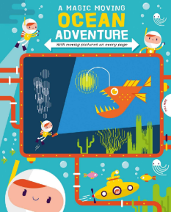

A Magic Moving Ocean Adventure – Igloo Books

How does your garden grow? - Cooking


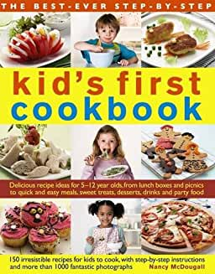
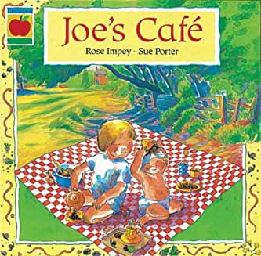

Joes Café - Rose Impey
Kids First Cook book - Nancy McDougall
Cool Kids Cook - Jenny Chandler

