

Wakefield Metropolitan District Council Family Services

Pinders Primary J. I and Nursery

Headteacher: Mrs L Kemplay

Eastmoor Road

Wakefield

WF1 3SQ

Telephone: 01924 303700

Website: [www.pindersprimary.co.uk](http://www.pindersprimary.co.uk)

Email: [headteacher@pindersprimary.org.uk](mailto:headteacher@pindersprimary.org.uk)

September 2023

Dear Parent/Carer

Swimming Lessons.

This half term your child will be taking part in swimming lessons. Lessons will take place on Thursdays. The lessons are part of the school curriculum and there is no charge.

Your child will need a swimming kit in a bag, consisting of a large towel, girls will need a one piece swimming costume (leggings are permitted but must be close fitting) a hair cap is optional. Boys will need lycra swimming trunks – not football/beach shorts, examples are shown below.

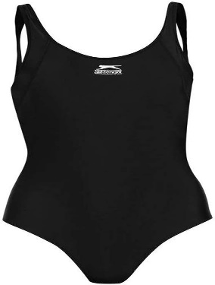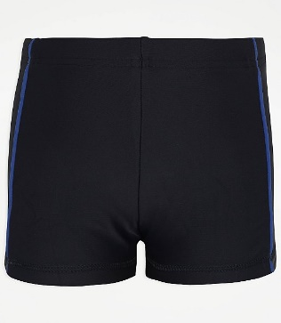

If you have any questions please feel free to speak to your child’s teacher or the school office.

Yours sincerely,

Mrs L Kemplay,

Head Teacher.